Understanding looked-but-failed-to-see accidents; the role of Inattentional Blindness

Final Report to the NRMA – ACT Road Safety Trust

Dr Kristen Pammer

September 2012

ACKNOWLEDGEMENTS

This research project was made possible as the result of a funding grant of $80593.00 by the NRMA – ACT Road Safety Trust. The work has been prepared exclusively by Dr Kristen Pammer (the grant recipient) and is not endorsed or guaranteed by the Trust.

I would like to thank the Research School of Psychology for supporting the research, and Dr Caroline Blink, and Erin Walsh for research assistance. I would also like to thank our participants and organisations who assisted in subject recruitment, including the Australian Federal Police, U3A, and the Country Woman’s Association, and Erin Walsh again for helping to construct this report

TABLE OF CONTENTS
Executive Summary 04
Background to project 06
General background and theoretical framework 06
Inattentional Blindness 07
Project Rationale 08
Methods 09
Participants 09
Stimuli 10
Visual Search 10
IB: Standard 10
IB: Driving 11
Continuous performance task 12
Demographic 13
Results 14
Inattentional Blindness and semantic congruency 14
Older vs. Younger drivers 17
Expert drivers 18
Summary 19
Implications and recommendations 21
Dissemination of results 23
Facilitation of associated research 24
Contributing factors 25
References 26
Appendix 1 demographic questionnaire 27
Appendix 2 article in press, refer attached
EXECUTIVE SUMMARY
Road accidents in which a driver fails to see another road user that is clearly in view are common. They are referred to as “looked-but-failed-to-see” accidents. The literature on “looked-but-fail-to-see” experiments is fragmented, poorly executed and highly specific. Yet such experiences map precisely onto a known psychological phenomenon called Inattentional Blindness (IB). This is where an observer fails to see an unexpected stimuli or event while attending to another, primary task. The aim of this project was to explore the factors that might increase or decrease incidences of IB in road users, and by extension, the human factors that increase or decrease “looked-but-failed-to-see” accidents.

We conducted a battery of test to determine the factors that might influence the detection of an unexpected object in a driving IB task. Our primary driving task consisted of a novel, static IB task where participants were presented with a sequence of driving snapshots. In each snapshot they were required to make a judgement of whether it was a ‘safe’ or ‘unsafe’ driving environment. A typical response here might be “it is safe because the driver has stopped at a red light”. There was no right or wrong answer, the judgement was required in order to get participants to attend to each snapshot. The task was to simulate the fast judgements all drivers are required to make when driving. In the 5th snapshot of the sequence, an unexpected object appeared and the participant was asked whether they detected an additional object in the snapshot. There were four conditions; participants were in either the ‘city’ or ‘country’ conditions, where the snapshots reflected city or country driving scenarios. In these, participants were further divided into congruent or incongruent conditions. The congruent condition was where the unexpected object was a business man in the city condition, or a kangaroo in the country condition. The incongruent condition is where the unexpected object was a kangaroo in the city or a business man in the country. In order to determine the cognitive and visuo-spatial factors that might influence detection of the unexpected object in the IB Driving task, we also measured: age, driving experience, tendency to make safe or unsafe judgements, visual search, vigilance using a continuous performance task, rumination, and a typical lab-based (non-driving related) dynamic IB task. Participants covered a wide demographic and we also had the opportunity to collect data on the 16 Australian Federal Police pursuit drivers. The AFP component of the study was not a part of the original research proposal, however the opportunity arose to include these drivers and we decided that it would substantially enhance the outcomes of the project to do so.

There were a number of findings from this study. Participants were more likely to detect the unexpected object in the city compared to a country environment, and were more likely to detect a congruent unexpected object compared to an incongruent unexpected object, however these results appeared to reflect the fact that city conditions were more familiar than country driving situations. Whether a participant had a tendency to report situations as ‘safe’ or ‘unsafe’ also predicted noticing the unexpected object. However these effects were depended on the age of the participant and their driving experience. No other factors predicted noticing the unexpected object, suggesting that some forms of hazard detection may be independent from the measured cognitive and visuo-spatial factors.

The results from this project suggest that the familiarity of the driving situation may be important in the way in which we tune attentional mechanisms such that we become more vigilant in an unfamiliar environment, but because we lack an attentional template for items that should exist in the environment, this vigilance does not manifest behaviorally into an increased tendency to spot unexpected items on the road. Conversely, in a familiar environment we may be less vigilant, but counter intuitively, more likely to detect an unexpected item particularly when it matches the semantic context.

We also demonstrated that well trained drivers such as the AFP drivers were more likely to detect the unexpected object, were less susceptible to the congruency effect and were overall more vigilant. These results were despite the evidence that the AFP drivers were no different from the unselected sample of drivers in all other cognitive and visuo-spatial measures.

The current project has provided enormous interest in additional studies of driving in our laboratory, and has formed the impetus for the development of a large ARC Linkage collaboration looking at highly trained driver processing and the implications for novice driver training.

BACKGROUND TO PROJECT
GENERAL BACKGROUND and THEORETICAL FRAMEWORK

In 2005 alone, 1481 people were killed across Australia in motor vehicle accidents, in 2003, 11096 people suffered serious injury. The primary cause for such accidents (33.7%) was attributed to “errors solely from inattention or misjudgement” (Australian Automobile Association Transport Statistics: http://www.aaa.asn.au/issues/statistics.htm)

A number of studies conducted across the world have now identified what have become known as “looked-but-failed-to-see” accidents. A typical example is a car driver that has failed to give way to another vehicle such as a bicycle or car. What makes such accidents unique is that the driver consistently maintains that they did not see the other vehicle. According to driver and police statements, the drivers are extremely surprised and shocked (Summala et al, 1996; Räsänen & Summala, 1998). Numerous examples are available where a car driver fails to see another car, a pedestrian, bicycle or motorcyclist, despite actually looking in that direction (Herslund & Jorgensen, 2003).

In the road safety literature, such slips of attention have been put down to insufficient visual search strategies, such that the driver fails to systematically move their eyes around the visual environment in a way that allows capture of all the relevant information (Summala, et al, 1996). Another explanation is that the ‘unseen’ item does not fit the driver’s current attentional expectations i.e., that the bicyclist comes from an unexpected direction.

There is little direct evidence for either theory, and the methodologies used in the experimental situations are weak. They have had small sample sizes, suffered from limited source information - such as self-report or insurance company data-bases (Koustanai, et al, 2008) - and tended to rely on the external environment rather than analyzing the cognitive state of the driver. The research in this area also tends to be restricted to highly specific examples of the driving situation, e.g., experienced drivers are less likely to see police cars parked in the direction of travel, than if parked at an angle (Langham et al, 2002).

However reports suggest that “looked-but-failed-to-see” accidents occur in a wide variety of situations: motorcyclists, bike riders, drivers changing a tyre on the side of the road, pedestrians, on main roads, country roads, intersections and roundabouts, as well as when overtaking. This is an important point, because, “looked-but-failed-to-see” accidents are all examples of a single underlying cognitive phenomenon called Inattentional Blindness (IB).

IB means we can draw on a single cognitive framework to explain all these incidences of “looked-but-failed-to-see” accidents. Although the phenomenon of IB is well known in the psychological literature, the parameters that cause it are still under investigation.

Inattentional Blindness
The most striking demonstration of IB is the “gorilla experiment” (Simons & Chabris, 1999). Observers are asked to track how often a ball is caught by three members of a team of people wearing white shirts and three members of a team of people wearing black shirts. Mid-way through the ‘tracking’ task, an actor in a gorilla suit walks though the six players, stops, thumps its chest, and walks off the scene. More than 60% of observers simply fail to see the ‘gorilla’ walk through the scene.

IB occurs when our attention is focused on another object or task, and we fail to see an unexpected object even if it stands exactly where our gaze falls (Koivisto, Hyönä & Revonsuo, 2004). The parallels with “looked-but-failed-to-see” accidents is clear – the driver’s attention is focused on driving the car, and they simply fail to see another road user that is clearly in their line of sight.

Recent IB research has adopted dynamic displays to test IB. In a typical design, subjects track multiple targets as they ‘bounce’ off the edge of the display. During this monitoring task, an additional, unexpected item will move across the display (refer to Figure 3 for an example. In the version of this task that we use in our lab, 60%-80% of observers fail to see the unexpected item (i.e., demonstrate IB). In other studies, observers have failed to see the item even when its colour and shape differ dramatically from the monitored items. For example, in one case, nearly a third of observers failed to see a bright red cross moving across a completely achromatic display (Most et al, 2001; Most, Scholl, Clifford & Simons, 2005).

Why IB occurs is still debated. There is evidence to suggest that at least some processing of the unseen item occurs and that varying the display parameters can make the unexpected item more, or less likely to be seen. For example, in the ‘gorillas’ experiment, observers were more likely to spot the gorilla if they were monitoring the ‘white’ team, and ‘smiley faces’ are more likely to be seen as an unexpected item than random shapes. This has led to at least two theories about IB. One explanation is an early stage model in which the item is seen, but rejected early in the visual processing stream based on its physical characteristics. The second is that the item reaches higher, but still unconscious awareness and is rejected based on how meaningful the stimuli is, or how well it matches the current attentional set. Most researchers would probably support the latter view, that most unattended visual stimuli are initially processed to the level of identification, but limited capacity attentional processes are needed to bring these visual representations into a state that can be consciously reported (Chun, 2002).

For more information about IB, see appendix 2 (Pammer & Blink, 2012). IB provides a valid theoretical model to explain “looked-but-failed-to-see” accidents in the real world.
Project rationale
This project was designed to explore the parameters that increase or decrease incidences of Inattentional Blindness, within the context of the driving experience in order to provide evidence for a core underlying cause in “looked-but-fail-to-see” accidents. In this we presented participants with a battery of relevant visuo-spatial and cognitive tests. The aim of the project was to explore the cognitive, perceptual and psychological factors that increase or decrease incidences of IB in the laboratory, and are therefore likely to be influential in “looked-but-fail-to-see” accidents on the road. Specifically, we investigated factors such as:
- Driving environment; does the driving environment influence a tendency to detect unexpected objects?
  - Experience; does familiarity or experience with a primary monitoring task influence rates of IB?
  - Are individuals more susceptible to IB as we age? Evidence suggests that central executive functioning decreases with age (Burke & Barnes, 2006), which would predict increases in IB,
however this factor may interact with experience, such that observers become more adept at ‘expecting-the-unexpected’, which would predict a decrease in rates of IB.
Multimodal processing; do cognitive perceptual factors including visual search performance, vigilance, and tendency toward rumination underlie the ability to detect unexpected stimuli?
The factor of individual differences and the influence of personality factors, specifically addressing whether a tendency to caution, and broader personal demographic issues such as hobbies, medication, or cognitive conditions impact on the ability to detect unexpected stimuli, was not addressed. This was due to too few participants responding to the relevant questions (see Appendix 1, questions 8 and 9).

METHODS
PARTICIPANTS
The majority of the participants were from the general public or students at the ANU. They participated for $20 remuneration or course credit. There were 150 participants, with an age range from 17 to 84.

Figure 1: Frequency graphs of relevant participant demographics
Driving experience for participants ranged from no driving experience (1 participant) to 62 years experience.
Please refer to Figure 1 for a full description of participant demographics. In addition to our unselected sample, we used a sample of 15 AFP fast pursuit drivers, all were male, aged between 26 and 46 years (M=38 years). They had between 10 and 44 years of driving experience (M=21), all reported a driving frequency of daily. They reported having between 1 and 10 accidents (M=3), and between 2 and 5 infringements (M=3).

Budgetary Adjustments
The original research proposal budgeted for 400 people at $10 each. However, we found it more difficult than expected to attract participants to the research in light of competing research in the department which was paying more than $10. Though this choice to double the remuneration halved the sample size that could be eventually achieved with the proposed budget, it allowed data collection to proceed on schedule, effectively increasing the sample size. The requirement to be competitive in the incentive offered is an important factor that has been considered for subsequent research proposals. This change to incentives given to participants is not expected to significantly impact subsequent recruitment for this research, as currently on-going data collection with an elderly sample (aged 50 and over) does not offer any monetary incentive. The decision not to offer an incentive was based on the observation that this older population is not presented with as many research projects competing for their attention.

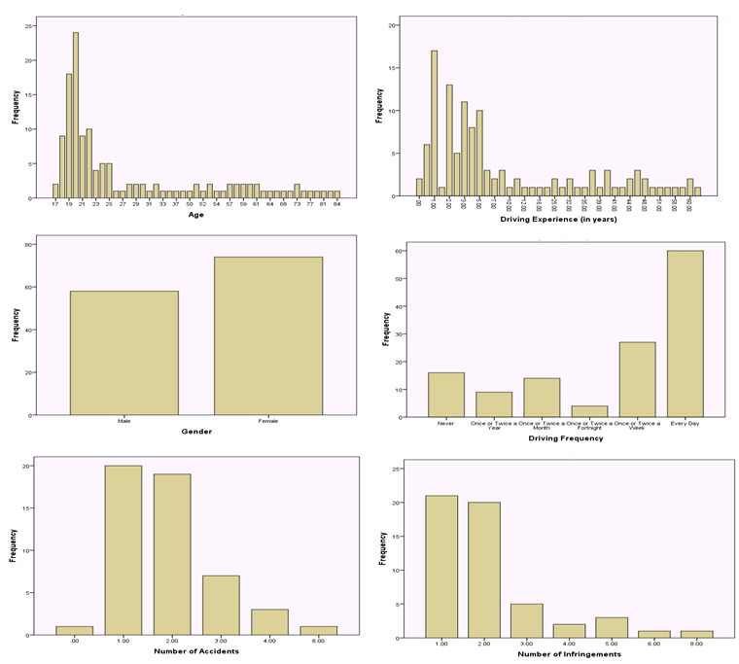

Figure 1: Frequency graphs of relevant participant demographics

STIMULI
Participants engaged in a range of Psychophysical tasks and questionnaires, testing took place at our laboratory at the ANU and took approximately 2 hours.

Visual Search
In this task participants were presented with a visual display consisting of a range of stimuli, the aim was to identify as quickly as possible a target in each display. The display was on the screen until the participant responded. In the Pop-Out Search, the target was easily identifiable as being distinct from the background items. In the Conjunction Search, the target was harder to detect as it was defined as a conjunction of features from the background items. Conjunction stimuli and pop-out stimuli were blocked with 35 trials per block for each stimuli set. Please refer to Figure 2 for examples of conjunction and pop-out stimuli. The dependent variable was accuracy and reaction time.
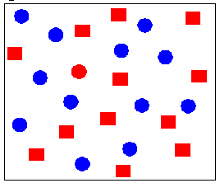
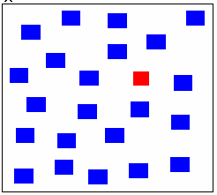
Figure 2: the left is an example of a conjunction search (target = red circle), and the right is an example of a pop-out search (target red square)

The aim of this task was to measure participant’s reaction times to detect and extract targets from cluttered visual scenes.

Inattentional Blindness: Standard
This task is derived from:
Beanland, V., Allen, R., & Pammer, K. (2011). Attending to music decreases inattentional blindness. Consciousness and Cognition, 20(4), 1282-1292.

Beanland, V., & Pammer, K. (2010). Gorilla watching: Effects of exposure and expectations on inattentional blindness. In W. Christensen, E. Schier, & J. Sutton (Eds.), ASCS09: Proceedings of the 9th Conference of the Australasian Society for Cognitive Science. Sydney: Macquarie Centre for Cognitive Science.

Beanland, V & Pammer, K. (2010). Looking without seeing or seeing without looking? Eyemovements in sustained inattentional blindness. Vision Research, 50, 977-988.

In this task the participant is presented with a stimuli (‘A’ in Figure 3) twice for 15 seconds each. They are required to count how many times the white letters bounce off the edge of the display. The participant then sees the critical trial - the IB trial, (B in Figure 3), which is identical, except that an unexpected item (the X in this example) moves across the centre of the screen. Stimuli ‘A’ is then presented again, and then on the 5th trial, there is another IB trial. Participants are then asked whether they saw any unexpected stimuli, and if so, to describe what they saw. Participants who report seeing nothing unexpected (experienced IB) are still asked to guess by pointing to a list of possible items which item might have appeared on the screen. The dependent variable is whether the participant detected the unexpected object.
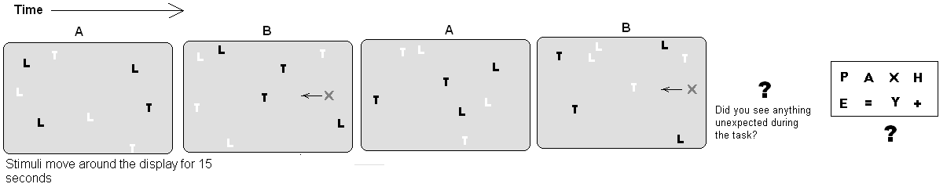
Figure 3: The test of Inattentional Blindness.
This is considered a ‘standard’ IB task in that we have used it extensively in our lab to investigate various factors related to IB. Here we were interested in whether the new static IB that we designed for this project (see IB Driving Scenario in next section) was consistent with the ‘standard’ IB task. This was to give us an indication of the replicability of the results, and also allowed us to explore differences between a standard lab-based IB task, and a more contextual task-relevant IB task.

Inattentional Blindness: Driving Scenario
In this task, participants were presented with a sequence of static driving images, each briefly flashed on the screen. In each image they were required to indicate if it was a ‘safe’ or ‘unsafe’ driving environment. The driving scenes were either of country driving environments, or city driving environments the ‘city’ and ‘country’ conditions were blocked such that each participant was in either a city or country environment. On the 5th trial, an unexpected object appeared that was either congruent with the preceding driving scenes (a kangaroo in the country or a business man in the city), or incongruent (a business man in the country or a kangaroo in the city). As with the ‘Standard’ IB task described in the previous section, after the 5th trial participants were asked whether they had seen the unexpected object (noticing the unexpected object was the dependent variable). We also recorded the ratings that each participant made (in regards to ‘safe’ or ‘unsafe’) to the trials preceding the critical trial. Please refer to Figure 4 for a schematic of the trial sequence and the different conditions.
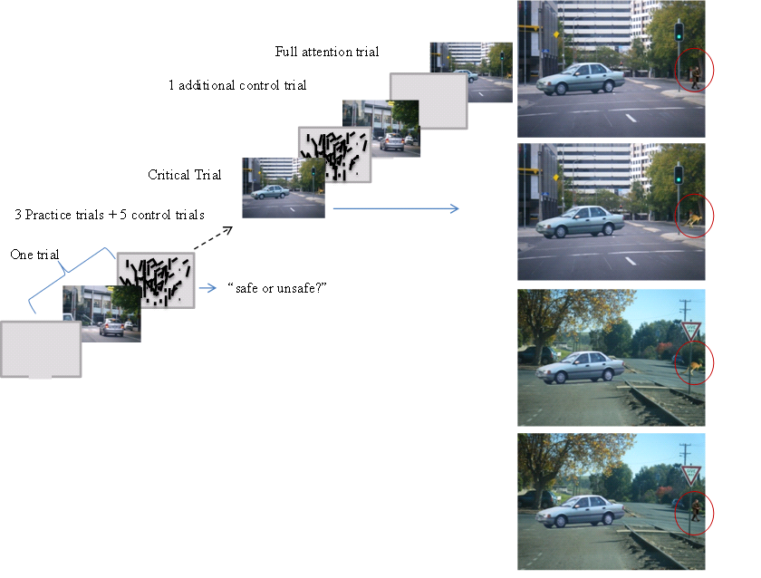
Figure 4: The Driving version of the IB task.
In addition to the unique combination of tasks used in this project, this particular task was highly innovative, and was the conceptual link back to actual driving experiences. This stimuli formed the basis of the publication: Pammer and Blink (2012) – please refer to Appendix 2

Continuous Performance Task
The continuous performance task was a task that was designed to test on-task performance and general vigilance. In this task, participants are presented with letter stimuli presented one after the other in the centre of the screen. The task is to hit a response button as quickly as possible when the target “X” is presented. Stimuli are blocked with 25 stimuli (5 targets) presented per block, and stimuli are presented in fast blocks (presentation time is 200ms per item), medium blocks (presentation time is 500 ms per item), and slow blocks (presentation time is 1.5 sec per item).
The task measures participant’s speed of processing for a target, and inhibition to distracter items. The typical finding here is that participants get slower and less accurate to the target as the presentation display slows down. This counter-intuitive finding is believed to reflect deterioration in vigilance and a tendency to ‘drift-off’ as stimuli presentation becomes more monotonous.

Demographic Questionnaire
Please refer to Appendix 1

RESULTS
Although the data was collected at the same time for all subjects, post-hoc evaluation of the outcomes suggest that the results reflect 3 broad areas; Inattentional Blindness and semantic congruency, older vs. younger drivers, and expert drivers. The most salient findings are presented here

INATTENTIONAL BLINDNESS AND SEMANTIC CONGRUENCY
(see also Pammer & Blink, 2012, the results presented below are adapted from this publication)
This component of the project used the IB: Driving scenario stimuli described above. Here we investigated whether participants were more or less likely to detect an unexpected object in an IB driving paradigm when the unexpected object was congruent or incongruent with the overall driving experience. We also considered the influence of driving experience, the familiarity of the driving environment, and the types of ‘safe’ or ‘unsafe’ judgements made.
IB for congruent and incongruent judgments
The overall rates of IB are presented in Figure 2. Pearson Chi-Square indicated borderline significance for the Road-Task x IB interaction χ² (3, N=95) = 7.56, p = .056.
Figure 5 suggests that overall rates of IB were higher in the city than in the country, but there is only a borderline effect of congruency. This marginal effect of congruency appears to be carried by the City condition, where there were higher rates of IB in the incongruent city condition (City/Kangaroo) compared to the congruent city condition (City/Businessman). This was confirmed statistically, in that the interaction between detection of the US and congruency condition was borderline significant in the City condition, χ² (1, N=48) = 3.0, p = .07 and not significant in the Country condition.

Figure 5 Rates of IB for the four road tasks background environment/unexpected stimulus.
Figure also indicates that the largest effect here is between City and Country scenes, in that it would appear that there is a higher rate of IB in the city conditions compared to the country conditions. This was confirmed statistically χ² (1, N = 95) = 5.036, p < .05, where the results were collapsed over congruency.
Driving experience
Logistic regression was performed to determine whether years of driving experience reliably predicted noticing the US. However, because the above analyses suggests that the differences between participants lie with whether they experienced the City or Country scenes, analyses were conducted separately.

In both the City and Country analyses, the predictor variable was Driving Experience in years, for noticing the US on the critical trial. In the City scenes the model was able to correctly classify 96% of observers who failed to see the US, and 36% of observers who saw the US for an overall success rate of 81.4%. The model indicates that driving experience significantly predicts IB in the city scenes, refer to Table 1.
Predictor | Condition | Β | S.E.β | Wald χ² | df | Odds Ratio | p
Driving Experience | City | .197 | .092 | 4.6 | 1 | 1.217 | .032
 | Country | -.072 | .098 | .54 | 1 | .93 | .462
Table 1: Logistic regression of US noticing for city scenes and country scenes

The Chi-square analyses indicate that participants with less driving experience were significantly less likely to see the US than those with more driving experience χ²(1, N=43) = 11.2, p < .002, refer to Figure 6. There was a difference in the average experience for noticers (N = 11, mean = 7.3 years driving, SD = 4.7) and non-noticers (N = 32, mean = 3.8 years driving, SD = 3.6), but this was
Figure 6. Rates of noticing the US categorized by driving
experience for the City and Country conditions.
of borderline significance t(41) = -2.3, p=.04, and also reflected the fact that three times as many people failed to notice the US. In the Country scenes, the full model was not reliably different from a constant-only model, indicating that in country scenes years driving did not predict whether a participant saw the US, refer to Figure 6. There was also no difference between driving experience for noticers (N = 19, mean = 2.7 years driving, SD = 1.6) and non-noticers (N = 20, mean = 3.5 years driving, SD = 5.4)

Overall the results indicate that the more driving experience a participant had, the less likely they were to miss the US (i.e., experience IB), however this effect was only significant for the City.

Type of judgments typically made
Overall participants made 10 ‘safety’ judgments. The variable TotalUnsafe was added to a logistic regression predicting noticing the US. For the City environment, the variable was not significant, whereas it was in the Country environment, where the model was able to correctly classify 85% of observers who failed to see the US, and 38% of observers who saw the US for an overall success rate of 63.8%.
Predictor |  |  |  | Condition |  | β | S.E.β | Wald χ² | df | Odds Ratio | P
TotalUnsafe Judgments | City | .142 | .228 | .388 | 1 |  | 1.15 |  | .533
 | Country | .725 | .275 | 6.97 | 1 |  | 2.065 |  | .008
Table 2. Logistic regression of US noticing for city scenes and country scenes with the predictor as the number of total unsafe judgments the participant responded with

Figure 7. Incidences of noticing the US based on whether participants were more or less likely to judge driving environments as safe or unsafe.

The chisquare analyses indicated that participants who were more likely to judge a scenario as safe, were significantly less likely to see the US than those participants who made mainly unsafe judgments χ²(1, N=47) = 9.26, p = .002, refer to Figure 7.
As is clear from Figure 7, participants in the city condition were far more likely to make
“safe” decisions than “unsafe” decisions, however this did not vary with whether or not they were likely to see the US. In the Country condition however, people who were more likely to make “safe” decisions were more likely to miss the US, whereas those people who were more likely to make “unsafe” judgments, were more likely to see the US.

OLDER VS. YOUNGER DRIVERS
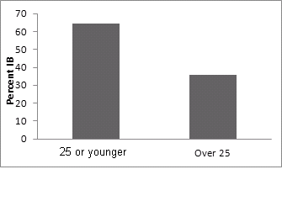
This data is still in the process of being analysed, however, preliminary results suggest the following:
There is currently a non-significant tendency for younger drivers to be less likely to detect an unexpected object compared to older drivers (refer to Figure 8). Although this effect is thus far non-significant, we are still in the processes of adding to this dataset.
Figure 8 Rates of IB for older and younger drivers

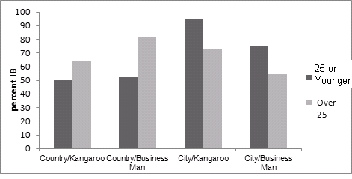
Younger subjects are more likely to be affected by the context.
Young drivers are more likely to experience IB in the city stimuli than the country stimuli (refer to Figure 9)

Figure 9: IB by age and condition

Figure 10. rates of IB for tendency to rate scenarios as safe or unsafe, by older/younger drivers.

For young people a tendency to judge the driving situation as safe results in higher rates of IB. Unsafe judgements result in a lower rate of IB (refer results from previous section). However, for older drivers the reverse is the case, Please refer to Figure 10. A tendency to judge situations as unsafe results in a greater tendency to miss the unexpected object (higher IB), whereas a tendency to judge situations as safe results in a greater tendency to detect the unexpected object.
In regards to visual search and the ‘standard’ IB task, results thus far suggest that older people are significantly slower and less accurate than younger participants.

EXPERT DRIVERS
This analysis involves comparing the 15 AFP pursuit drivers with the unselected sample of drivers. The results here are limited by low power.

The AFP drivers were compared with the general public and ANU sample (the “unselected” sample). They demonstrate that AFP drivers are almost twice as likely to detect an unexpected object in the IB: Driving task (refer to Figure 11), and are less likely to be susceptible to incongruency (because of low numbers, the AFP driver only participated in the City congruent/incongruent conditions), refer to Figures 11 and 12. ‘Unselected’ here refers to the fact that no criteria such as age or experience were applied to the data.

Figure 11: Rates of IB for AFP drivers Figure 12: Rates of noticing for congruent and incongruent conditions
The Standard IB task demonstrated no differences between AFP drivers and the unselected sample of drivers, and there was no difference in accuracy or speed of processing for the visual search task.
However, there was a difference between AFP drivers for the Continuous Performance Task, such that AFP drivers maintained attention over all three stimulus presentation conditions, whereas the unselected sample increased accuracy over the three conditions. Refer to Figure 13.
Because of the large differences numbers for the AFP and unselected groups, ANOVA’s were conducted separately and indicated a significant increase in RT over Fast, Medium Slow for the unselected group F(2,200) = 19.3, p <.001, and no significant increase for the AFP group F(2,28), = .994, p = 383

Figure 13: AFP drivers and the unselected sample
for the 3 different Continuous Performance presentation
conditions

SUMMARY
This project is designed to explore the parameters that increase or decrease incidences of Inattentional Blindness, within the context of the driving experience in order to provide evidence for a core underlying cause in “looked-but-fail-to-see” accidents. We explored the following to determine the influential factors in the tendency to detect the unexpected object in an IB Driving scenario:

- Attentional set of the driving situation, in this case a ‘country’ or a ‘city’ driving environment
- Whether a new, static, IB Driving task involves the same processes as a ‘standard’ IB task.

We also explored the following, grouped according to the current project’s objectives:

Experience
c) Driver’s experience
d) Familiarity with the driving situation
e) Driver training (AFP drivers)

Are individuals more susceptible to IB as we age?
f) Driver’s age

Individual differences and the influence of personality factors
g) Tendency to caution (tendency to report situations as ‘safe’ or ‘unsafe’)
h) Personal demographics such as hobbies, medication or cognitive condition (such as ADHD)

Multimodal Processing
i) Whether cognitive-perceptual factors such as visual search (the ability to detect an object in a cluttered surround), vigilance (the continuous performance task), tendency toward rumination might underlie detection of the unexpected stimuli

The following results were found:
a) Attentional set does influence tendency to detect the unexpected object. Participants were more likely to detect an unexpected object in a city scene compared to a country scene. They were also more likely to detect a congruous stimuli (man in a business suit) compared to an incongruous stimuli (a kangaroo).
b) The ‘standard’ IB task was not related to the new Driving IB task.
c) Experience predicted detection of the unexpected object, such that drivers with more experience were more likely to detect the unexpected object, but this was only for the familiar city scene.
d) Results in a) may be influenced by the familiarity of the driving situation such that drivers were far more likely to drive in cities than the country. If this is the case, then participants are more likely to detect unexpected objects in familiar compared to unfamiliar driving situations
e) Trained AFP pursuit drivers were more likely to detect the unexpected object, but less likely to be influenced by semantic congruency. AFP drivers did not differ from other drivers on any other measures except continuous performance suggesting a higher level of vigilance.
f) Older drivers are more likely to detect an unexpected object and be less likely to be influenced by the congruency of the driving situation and the unexpected object.
g) In the familiar City condition there was a tendency to make “safe” rather than “unsafe” judgments compared to the unfamiliar Country, but this did not contribute to whether a participant was more or less likely to detect the US. In the Country condition, participants’ who were more likely to respond to trials as being “unsafe”, were also more likely to detect the US.
h) Personal factors were recorded, but not assessed statistically as there was insufficient numbers to reflect specific hobbies or cognitive conditions
i) No visual or cognitive factors predicted noticing the unexpected object in the Driving IB task.

IMPLICATIONS AND RECOMMENDATIONS
It is likely that the development of a specific attentional set is an unavoidable and in fact necessary consequence of driving. The important practical outcomes in this case are to foster an increased awareness that our familiarity with the driving situation strengthens our attentional set, and this has consequences for our ability to detect hazards and our vigilance. However the current finding also has implications for other road users. For example, motorcycle accidents are over-represented in road accident statistics, thus we are currently exploring the possibility that motorcycles are less likely to fit our attentional set when driving thus translating into a decreased tendency to detect a motorcycle compared to a car.

The results from the current project suggest that the familiarity of the driving situation may be important in the way in which we tune attentional mechanisms such that we become more vigilant in an unfamiliar environment, but because we lack an attentional template for items that should exist in the environment, this vigilance does not manifest behaviorally into an increased tendency to spot unexpected items on the road. Conversely, in a familiar environment we may be less vigilant, but counter intuitively, more likely to detect an unexpected item particularly when it matches the semantic context.

Older drivers judge the driving situations differently and are generally less likely to experience IB
Those who do experience IB are less likely to be influenced by the type of driving situation.
Judging driving situations as unsafe appears to make older drivers more vigilant in the driving situation. Thus although older drivers may show decreased visuo-spatial perception, they appear to be better than younger drivers in terms of the detection of unexpected objects in the driving situation. This finding is very preliminary and requires further research.

Despite the fact that we had only 16 AFP pursuit drivers, this is one of the more intriguing findings. The AFP drivers were better at detecting unexpected objects in the driving situation and were more vigilant overall, but their overall visuo-spatial sensitivity was consistent with the unselected sample of drivers. This was independent of driving experience thus we surmise that their superior processing is the consequence of specific driver training. This finding is however limited by the small number of participants even though we tested all pursuit drivers available in the ACT. This finding has prompted the development of a further grant to explore the consequence of specific driver training and the implications for novice driver training.

Finally, from the perspective of cognitive models of attention and IB, it appears that detection of an unexpected object in IB is not predicated on basic visual processes such as visual search, general vigilance or rumination. Moreover, a static, contextual IB task such as our IB Driving task is unrelated to a dynamic IB task. The cognitive literature makes the assumption that static and dynamic IB reflect the same basic attentional processes. These results suggest that this assumption may be unfounded. However this finding requires confirmation and further research.

DISSEMINATION OF RESULTS
The results from the IB: Driving Scenario study has been accepted by Accident Analysis and Prevention. Please refer to attached manuscript. The results from this study were also presented at the International Congress of Psychology; South Africa, 2012.

The data pertaining to the differences between younger and older drivers is currently in preparation as another scientific manuscript to be submitted to Accident Analysis and Prevention. We anticipate submission by December 2012.

The findings with the AFP drivers will be written up in a more dedicated journal, such as Police Practice and Research. We anticipate submission by December 2012

FACILITATION OF ASSOCIATED RESEARCH
This project has generated enormous interest in the phenomenon of IB in general, and its role in driving. As a consequence of this, we now have two PhD students, and four honours students specifically investigating IB. Our projects over the last two years have included; IB and mobile phone use (Beanland, 2011), the role of IB in the attentional development of children (Musitano and Pammer, 2011), theoretical links between IB and Attentional Blink, semantic encoding in IB, semantic encoding in driving and hazard detection (Pammer & Blink, 2011), IB and motorcycle detection when driving (Sabadas, 2012), driving and attentional requirements in the elderly (Carter & Pammer, 2010). Thus, although this project was designed to be a self-contained unique project, it fulfilled these objectives and additionally provided a framework for ongoing student projects and academic collaborations. For example, Dr Jay Brinker, and Dr Jason Bell – who is on another ARC grant application motivated by this project, Dr Vanessa Beanland who is at the Monash Accident Research Centre, the CSIRO and Questacon who expressed ongoing interest in the project and have allowed us to collect data in those locations. We similarly developed collaborations with the AFP looking at the performance of pursuit drivers. We intend to develop these collaborations and establish new ones with ACT Ambulance Service Australia who have similar driver training processes as the AFP. Thus previous Trust support research resulted in a 10-fold increase in research interest and the acquisition of technology.
The project has also provided the motivation for a subsequent Australian Research Council Linkage grant with the NRMA-ACT Road Safety Trust, and ACT Ambulance Service. We anticipate that this grant will be submitted in the November 2012 funding round.

CONTRIBUTING FACTORS
The primary difficulty we encountered was liaising with the ANU financial sector. The ANU science administration went through a major transition, approximately six months into the project where the financial management of all research projects was decentralised from university to college level administration. Sometime after this process we received correspondence from financial management that we interpreted to mean the project budget had been reached – I was somewhat surprised, but trusted the admin directive. As a consequence data collection by the research assistant stopped, and I commenced the data analysis and writing up the data collected thus far. Some six months later I learned from the NRMA-ACT Road Safety Trust that in fact we still had some substantial funds left – certainly enough to collect more data. The problem now however, was that the project had gone on hold for over six months, and it was the end of the year (2011), and it is notoriously difficult to get participants to come into the university over the summer break. In addition to this, my research assistant Dr Caroline Blink left the university at the start of this year to take up a full time position with the ABS. This necessitated me acquiring and training a new research assistant. As a consequence of this, the project ran substantially over time. However, despite this, dissemination of project outcomes still occurred in terms of a published study and conference presentations, even though the project had not been fully completed, indicating the internal integrity of the design that multiple stages of the data collection were able to be presented as unique pieces of research.

REFERENCES
Barkley, R., Murphy, K., & Kwasnik, K. (1993). Motor vehicle driving competencies and risks in teens
and young adults with attention deficit hyperactivity disorder. Pediatrics, 98, 1089-1095
Burke, S., & Barnes, C. (2006). Neural plasticity in the aging brain. Nature Reviews Neuroscience, 7,
30-40
Caird, J., Willness, C., Steel, P., & Scialfa, C. (2008). A meta-analysis of the effects of cell phones on
driver performance. Accident Analysis and Prevention, 40, 1282-1293
Chun, M., Marois, R. (2002). The dark side of visual attention. Current Opinion in Neurobiology, 12,
184-189.
Haines, R. F. (1991). A breakdown in simultaneous information processing. In G. Obrecht & L. W.
Stark (Eds.), Presbyopia research: From molecular biology to visual adaptation (pp. 171–175).
New York: Plenum.
Herslund, M.-B., Jorgensen, N.O., 2003. Looked-but-failed-to-see-errors in traffic. Accident Analysis
and Prevention. 35, 885–891.
Koivisto, M., Hyönä, J., & Revonsuo, A. (2004). The effects of eye movements, spatial attention, and
stimulus features on inattentional blindness. Vision Research, 44, 3211–3221.
Koustanai, A., Boloix, E., Van Elselande, P., & Bastien, C. (2008). Statistical analysis of “looked-but-
failed-to-see” accidents: Highlighting the involvement of two distinct mechanisms. Accident Analysis and Prevention, 40, 461-469.
Langham, M., Hole, G., Edwards, J., O’Neil, C., 2002. An analysis of “looked-but-failed-to-see”
accidents involving parked police vehicle. Ergonomics 45, 167–185.
Mack, A., & Rock, I. (1998). Inattentional blindness. Cambridge, MA: The MIT Press.
Most, S. B., Simons, D. J., Scholl, B. J., Jimenez, R., Clifford, E., & Chabris, C. F. (2001). How
not to be seen: The contribution of similarity and selective ignoring to sustained inattentional blindness. Psychological Science, 12, 9-17.
Most, S. B., Scholl, B. J., Clifford, E. R., & Simons, D. J. (2005b). What you see is what you set:
Sustained inattentional blindness and the capture of awareness. Psychological Review, 112, 217-242.
Räsänen, M., Summala, H., 1998. Attention and expectation problems in bicycle–car collisions: an in-
depth study. Accident Analysis and Prevention. 30, 657–666.
Simons, D. J., & Chabris, C. F. (1999). Gorillas in our midst: Sustained inattentional blindness
for dynamic events. Perception , 28, 1059-1074.
Strayer, D., Drews, F., & Johnston, F. (2003). Cell phone-induced failures of visual attention during
simulated driving. Journal of Experimental Psychology – Applied, 9, 23-32.
Summala, H., Pasanen, E., R¨as¨anen, M., Siev¨anen, J., 1996. Bicycle, accidents and drivers’ visual
search at left and right turns. Accident Analysis and Prevention. 28, 147–153.
Wickens, C., Toplak, M., & Wiesenthal, D. (2008). Cognitive failures as predictors of driving errors,
lapses, and violations. Accident Analysis and Prevention, 40, 1223-1233.

APPENDIX 1

NRMA Road Safety Study

Please write your personal research code in the space provided below

Personal Research Code___________________________________
(M for male or F for female, First two letters of your mother’s first name, Your birth date excluding the year, eg mine is FMA2301)

Driving Experience
- Do you hold a current driver’s licence? Yes / No (Please circle)

- If yes, how many years have you had a driver’s licence? _______

- In general, how frequently do you drive?
  - Every day
  - Once or twice a week
  - Once or twice a fortnight
  - Once or twice a month
  - Once or twice a year
  - Never

- Have you ever had an accident while driving? Yes / No (Please circle)

If no, please move on to question 7.

- How many accidents have you had? _______

- Please briefly describe the circumstances of each accident:

- Have you ever had a traffic infringement notice? Yes / No (Please circle)

If no, please move on to question 10.

- How many have you had? _______

- What do you most commonly receive infringement notices for?

- Do you ever engage in potentially dangerous driving practices for which you have not received an infringement notice (e.g. speeding, drinking and driving)?
Yes / No (Please circle)

If no, please move on to the next section.

- What types of potentially dangerous driving practices do you engage in and how frequently?

Demographic Information
- Age: _________

- Gender: Male / Female (Please circle)

- Occupation: _______________

- Do you have any health-related issues (e.g., heart problems, ADHD, epilepsy)?
Yes / No (Please circle)

- If yes, please specify:

- Do you take any prescription medication? Yes / No (Please circle)

- If yes, what types of medication are you taking:

- Do you have any hobbies that use driving-related skills (e.g., gaming)?
Yes / No (Please circle)

- If yes, please specify:

APPENDIX 2

Please refer to attached manuscript Pammer & Blink (2012)

