Research Report ARR 364
July 2005
Young drivers:
Who takes risks and why?
John Catchpole
Tanya Styles

Information Retrieval
Catchpole J and Styles T (2005). Young drivers: Who takes risks and why? ARRB Group Ltd, Vermont South, Victoria, Australia. Research Report ARR 364. 63 pages, including figures, tables and appendices.
The aim of this study was to provide a sound basis for the development of measures to reduce risk-taking among young novice drivers. The objectives were to identify the groups of young driver most likely to engage in risky driving behaviour; and to assess the importance of age, experience, over-confidence, aversive consequences and parental risky driving as influences on risk-taking by young novice drivers. The study comprised a telephone survey of young ACT drivers and an analysis of traffic offence data for recently-licensed ACT drivers.
The rate of risky traffic offences was found to be much higher for young males than for young females. Risky offence rates declined steeply with increasing age. After controlling for the effect of age, traffic offence rates were found to remain fairly constant for the first three years of driving experience, before rising sharply in the fourth year. For both males and females, the offence rate was far higher for drivers who had committed prior offences than for drivers who had not. Risky offences continue at relatively high rates even after the driver’s licence has been suspended or cancelled. Over-confidence was found in the telephone survey to contribute to speeding, using a hand-held mobile phone while driving and running red lights, but not to aggressive driving. Survey respondents explicitly acknowledged the influence of both their fathers’ and their mothers’ driving on their own driving style. There were statistically significant associations between the self-reported frequency of risky driving behaviours by the respondent and the frequency of their parents engaging in the same behaviours.

ARR 364
July 2005
ISBN 1 876592 39 7
ISSN 0 158-0728
© ARRB Group Ltd.  All rights reserved. Except for fair copying, no part of this publication may be reproduced, stored in a retrieval system or transmitted in any form or by any means, electronic, mechanical, photocopying or otherwise, without the prior written permission of ARRB Group Ltd.  Although the Report is believed to be correct at the time of publication, ARRB Group Ltd, to the extent lawful, excludes all liability for loss (whether arising under contract, tort, statute or otherwise) arising from the contents of the Report or from its use. Where such liability cannot be excluded, it is reduced to the full extent lawful. Without limiting the foregoing, respondents should apply their own skill and judgement when using the information contained in the Report.  Wholly prepared by  ARRB Group Ltd  500 Burwood Highway  Vermont South Vic 3133  Australia  Contact: Publication Sales  ARRB Group Ltd  Phone 61 3 9881 1561  Fax 61 3 9887 8144  E-mail booksales@arrb.com.au | About the authors  John Catchpole  John Catchpole joined ARRB in 1988 and currently holds the position of Senior Research Scientist. He holds a Bachelor of Science degree with first class honours (majoring in psychology) from Monash University and a Bachelor of Science degree (majoring in mathematics) from the University of Melbourne. In 1997, he was awarded the degree of Master of Applied Science by La Trobe University for his research on accidents involving young drivers.  John is the author of over 100 published and unpublished research reports and conference papers. His areas of research expertise include: accidents involving young drivers; driver assessment for licensing; the contribution of driver behaviour and environmental factors to accidents; and pedestrian behaviour and perceptions. | Tanya Styles  Dr Tanya Styles joined ARRB in November 2002. In 2003 she received her Doctorate in Health Psychology from Deakin University. Tanya’s thesis involved an investigation of the utility of a health behaviour model that has been applied to predict many behaviours, including the commission of driving violations.  Tanya’s areas of expertise include early childhood road safety education; data analysis; attitude and behaviour measurement; and models of behaviour change.

ARRB Group Ltd
ACN 004 620 651
ABN 68 004 620 651

HEAD OFFICE
500 Burwood Highway
Vermont South
Victoria 3133
Australia
Tel: 61 3 9881 1555
Fax 61 3 9887 8104
E-mail info@arrb.com.au
Internet: www.arrb.com.au

OTHER OFFICES
New South Wales
Queensland
South Australia
Western Australia
Indonesia
Contents
Acknowledgements and Disclaimer iv
Summary v
1 Introduction 1
1.1 Background 1
1.2 Objectives 2
1.3 Tasks 2
2 Telephone survey 2
2.1 Method 2
2.1.1 Respondents 2
2.1.2 Instruments 2
2.1.3 Procedure 3
2.2 Results and discussion 3
2.2.1 Data checking 3
2.2.2 Sample characteristics 4
2.2.3 Frequency of four risky driving behaviours 7
2.2.4 Self-reported reasons for risk-taking 8
2.2.5 Risk-taking by demographic groups 11
2.2.6 Influence of parents 23
2.2.7 Influence of gender, age, experience and over-confidence 26
2.3 Summary 31
2.3.1 Prevalence of risk-taking among ACT novice drivers 31
2.3.2 Reasons for risky driving 31
2.3.3 Demographic factors 32
2.3.4 Influence of parents’ driving style 32
2.3.5 Influence of gender, age, experience and over-confidence 32
3 Traffic offences 33
3.1 Method 33
3.1.1 Data source and preparation 33
3.1.2 Risky and non-risky offences 33
3.1.3 Driver and offence selection 34
3.1.4 Calculation of offence rates 34
3.2 Results 34
3.2.1 Gender and age 34
3.2.2 Experience 36
3.2.3 Licence type 38
3.2.4 Previous offences 39
3.2.5 Other licence-related events 41
3.3 Discussion 41
3.3.1 Limitations 41
3.3.2 Influence of gender, age and experience on risky driving 42
3.3.3 Drivers with prior offences 43
3.3.4 Other influences on risky driving 43
4 Conclusions 44
4.1 Extent of risky driving among young drivers in the ACT 44
4.2 Influences on risky driving 44
4.3 Target groups for countermeasure development 45
References 46
Appendix A—Survey questionnaire 48
Appendix B—Preparation of licence and offence data for analysis 62
Licence holders 62
Offences 62

Acknowledgements and Disclaimer

This report has been prepared by John Catchpole and Tanya Styles for ARRB Group Ltd using sponsorship funds from the NRMA–ACT Road Safety Trust. The report is the exclusive work of ARRB Group Ltd and the Trust accepts no responsibility for the contents of it, nor does it assume any duty of care to any person who might act in reliance of its contents.

The authors gratefully acknowledge the valuable comments made by Dr Peter Vulcan and Dr Peter Cairney, who reviewed earlier drafts of the report.

Summary
Background
Reviews of research into young novice drivers have consistently found that risky driving behaviours make an important contribution to the over-representation of young drivers in traffic accidents. Whilst the link between risk-taking and youth is firmly established, recent research by ARRB Group has identified several other factors that appear to contribute to risk-taking in the early years of driving. These include over-confidence, habit and modelling of risky driving behaviour by parents.
Objectives
The aim of this study was to provide a sound basis for the development (in a future project) of measures to reduce risk-taking by young novice drivers. The objectives of the study were to extend the findings of previous studies by:
- identifying and defining the sub-population of young novice drivers in the Australian Capital Territory (ACT) most likely to engage in risky driving behaviour
- quantifying the influence of age and experience on self-reported risk-taking by young novice drivers
- assessing the importance of over-confidence, aversive consequences, habit formation and parental risky driving as influences on risk-taking by young novice drivers.
Method
The study comprised two major tasks:
- a telephone survey of young ACT drivers
- an analysis of traffic offence data for recently-licensed ACT drivers.
Telephone survey: The sample comprised 300 males and 100 females aged 17–21 years who held a provisional or full driver licence and drove a car, utility or van at least twice per week on average. The survey was conducted on behalf of ARRB by an experienced market research company using computer-assisted telephone interviewing. The survey questions collected information about the frequency with which respondents and their parents engaged in four risky driving behaviours: speeding, using a hand-held mobile phone while driving, red light running and aggressive driving. Other questions elicited the reasons for risky driving behaviour and various experiences and beliefs related to over-confidence. The questionnaire appears in Appendix A.
Traffic offence analysis: Information about all traffic offences committed by drivers first licensed during the period January 1994 to December 2004 was supplied by the Rego.ACT section of the ACT Department of Urban Services. Offences were classified as risky if they involved speeding, alcohol, running a red or yellow traffic signal, using a hand-held phone while driving, failing to wear a seat belt, careless or negligent driving, failing to give way, failing to signal, unaccompanied driving by a learner, wrong way driving, improper turns, improper overtaking, driving without headlights at night, carrying unrestrained passengers, burnouts, street racing, disobeying certain critical signs or parking/stopping/standing in a manner described as ‘dangerous’. Non-risky offences were excluded from the analysis. Offences relating specifically to bicycles, motorcycles, heavy vehicles, pedestrians and passengers were also excluded.
Factors found to influence risky driving behaviour
Gender: The self-reported frequency of speeding, using a hand-held mobile phone while driving and driving aggressively among survey respondents was slightly higher for males than for females, although only for aggressive driving did the gender difference emerge as significant in the logistic regressions. The influence of gender on risky traffic offences was much more clear-cut, with the rate per thousand drivers per year for males being roughly double that for females. Exposure differences explain the higher rate of risky offences for males only to a minor extent. It seems likely that gender differences in risk-taking are largely the result of physiological differences and/or the differing social expectations applying to young males and females.
Age: There was no apparent effect of age on self-reported risk-taking for the four risky behaviours examined in the telephone survey; however, it should be noted that survey respondents were restricted to a narrow age range (17–21 years). Examination of the rate of risky traffic offences per thousand drivers per year revealed a clear decrease in risk-taking with increasing age, especially for males. The influence of age was even more apparent once the effect of experience was removed, with drivers in each experience group showing a steep decline in offence rates with increasing age.
Experience: Logistic regression revealed that speeding, the most commonly reported of the four risky behaviours examined in the telephone survey, was significantly influenced by driving experience, with respondents who had held a solo licence for longer being more likely to report speeding at least occasionally over the last few weeks. Experience also had a statistically significant effect on the frequency of aggressive driving: the more hours of driving experience the driver had accumulated since acquiring a provisional licence, the more likely it was that the driver would report having driven aggressively in the last few weeks. After controlling for the effect of age, traffic offence rates were found to remain fairly constant for the first three years of driving experience, before rising sharply in the fourth year. It seems likely that this increase is related to the relaxation of BAC and demerit point restrictions when graduating from a provisional licence to a full licence, rather than to the effect of experience per se. Increased consumption of alcohol may lead to increased risk-taking even among drivers who do not exceed the legal BAC limit. The higher demerit point limit applying to full licence holders removes an important inhibiting factor and may result in increased willingness to take risks.
Habit: Telephone survey respondents offered a variety of reasons for engaging in risky behaviours, most of which related to the utility of the behaviour, to over-confidence or to the actions of other road users. None of the responses implied that the formation of driving habits contributed to the performance of risky driving behaviours. Although respondents did not mention habit, its involvement cannot be ruled out on the basis of the present study. It would be desirable to investigate this issue further by other methods.
Over-confidence: The reasons offered by telephone survey respondents for engaging in each of four risky driving behaviours implied that over-confidence contributes to speeding, using a hand-held mobile phone while driving and running red lights, but not to aggressive driving. However, neither higher levels of confidence nor lower expectations of adverse consequences were found in the logistic regressions to be significantly associated with higher levels of risk-taking. On the contrary, not believing oneself to be safer than other drivers of the same age and gender was found to be associated with more frequent speeding and aggressive driving, suggesting an accurate rather than an over-confident self-assessment. The contribution of over-confidence to the increase in risk-taking with driving experience requires further investigation.
Risky driving by parents: The telephone survey clearly revealed the influence of parental driving style on risk-taking by respondents. Respondents explicitly acknowledged the influence of their fathers’ and their mothers’ driving on their own driving style. In addition, there were statistically significant associations between the self-reported frequency of risky driving behaviours by the respondent and the frequency of their parents engaging in the same behaviours. All associations were positive, with a higher frequency of risky behaviour by the parent being associated with a higher frequency of the same risky behaviour by the young driver.
Target groups for countermeasure development
The study clearly identified several potential target groups for the development of measures to reduce risky driving behaviour. Different countermeasures are required for the different target groups.
The primary focus of efforts to reduce risky driving offences should be on drivers who have already committed at least one risky driving offence, since they are more likely than other drivers to offend in the future. The impact of prior offences on future offence rates is greater than the effect of either gender or age, so focussing on drivers with prior offences is the most efficient way of identifying potential future offenders.
After prior offences, the next most important influence on the frequency of risky driving behaviour is gender, with young males admitting to more frequent risky behaviour and having roughly twice as many risky offences per driver as young females. Optional programs, such as the ACT’s existing Road Ready Plus program, should be marketed in ways that appeal particularly to males. Furthermore, the content of all programs intended to reduce risk-taking, whether mandatory or optional, should be designed to cater especially for the needs of male participants.
High levels of risky driving are associated specifically with youthfulness rather than with lack of driving experience. Older novice drivers have a much lower rate of risky driving offences than do younger novice drivers. Programs intended to reduce the frequency of risky driving should focus on the youngest drivers rather than the least experienced drivers.
Offence rates indicate that, particularly among males but also to some extent among females, significant levels of risk-taking continue even when the driver’s licence is suspended, cancelled or disqualified. Indeed, the rate of risky offences is higher among males currently banned from driving than among females overall (the vast majority of whom are not banned) and approximately equal to the rate among males with no prior offences. Thus there is a clear need to address risky driving by people, especially males, who are currently banned from driving. This might be achieved by an enforcement campaign targeting those who continue while banned, supported by appropriate publicity.
The substantial increase in the rate of risky offences in the fourth year of driving implies a need for a program aimed at drivers who are about to graduate from a provisional licence to a full licence. It may be possible to reduce risk-taking among new full licence holders by educating them about the effect of alcohol on driving behaviour at legal BACs as well as illegal BACs. To reduce the impact of the increase in the demerit point limit when graduating from a provisional to a full licence, it would be worth considering a graduated increase, for example by two points per year over the first four years of holding a full licence. Thus the limit would be six points in the first year of holding a full licence, eight points in the second year, increasing to a maximum of twelve points by the fourth year. This would require a corresponding adjustment to the demerit point incentive offered to drivers to complete the Road Ready Plus program. Drivers could commence the graduated increase from four to twelve points immediately on completion of Road Ready Plus, without having to wait until they hold a full licence.
The links established by the present study between the risk-taking of novice drivers and their parents suggest that risk-taking by novices could be reduced by programs that address risky driving by the parents of pre-driving-age children. A program aimed at parents should probably focus on the parents of pre-driving secondary school students.

Introduction

Background
Reviews of research into young novice drivers have consistently found that risky driving behaviours make an important contribution to the over-representation of young drivers in traffic accidents (e.g. Goldstein, 1972; Lewis, 1985; Jonah, 1986; Macdonald, 1994; Catchpole, Cairney and Macdonald, 1994; Ferguson, 2003; Senserrick and Whelan, 2003). Recklessness—or willingness to take risks—has been found to be associated with accident involvement of young drivers by Harrington (1972) and Catchpole, Macdonald and Bowland (1994). Risky behaviours in which young drivers are known to be particularly likely to engage include red light running (Konecni, Ebbesen and Konecni, 1976, cited by Jonah, 1986), close following (Evans and Wasielewski, 1983), failure to wear seat belts (Jonah and Dawson, 1987) and speeding (Goldstein, 1972; Evans and Wasielewski, 1983; Fildes, Rumbold and Leening, 1991; Catchpole, Cairney and Macdonald, 1994).
Whilst the link between risk-taking and youth is firmly established, recent research by ARRB Group has identified several other factors that appear to contribute to risk-taking in the early years of driving.
Studies of young driver involvement in accidents in Victoria (Catchpole, Cairney and Macdonald, 1994) and New South Wales (Catchpole, 1998) have indicated that, among drivers of the same age, those with more experience of driving may be more likely to engage in risky driving behaviour than those with less experience. A recent study of traffic offences in NSW (Catchpole, 2005) provided strong support for this by demonstrating that, among drivers of the same age, higher levels of experience (up to approximately two years from the issue of a provisional licence) are associated with a higher traffic offence rate per thousand drivers. The analysis conducted during this study, however, did not allow the researchers to determine whether this increase was caused by (i) the majority of the more experienced drivers having learned that risky driving behaviour is not likely to be followed by unpleasant consequences, or (ii) a higher level of confidence among the more experienced drivers that they can safely negotiate hazards if they arise.
Recent research conducted for the NRMA-ACT Road Safety Trust by ARRB (Styles, Imberger and Catchpole, 2004) revealed a surprisingly high level of self-reported risk-taking by some young male novice drivers in the ACT. The study found evidence that both of the previously-suggested mechanisms contribute to risk-taking as driving experience increases. For example, responses given during group interviews indicated that most (though not all) drivers learn through experience that risky driving behaviours are unlikely to be followed by unpleasant consequences such as a fine or an accident. Many drivers also feel increasing confidence in their ability to control their vehicles, deal with hazards if they arise, avoid involvement in accidents and avoid detection by police.
The focus group study also found indications that the willingness of young males to engage in risky driving behaviour is influenced by the driving style of their parents. Little empirical work has been done to identify a link between the parents’ and young drivers’ behaviours in relation to risky driving practices. One way in which behaviours are learned is through ‘modelling,’ which is essentially the learning of a behaviour through observing somebody else engaging in it. Most Australian children are exposed to their parents’ driving for many years before they get behind the wheel themselves, at which point many will have little to guide them apart from the direction of their driving instructor (often their parent) and what they have seen their parents do as drivers. It is therefore not unreasonable to expect young drivers to exhibit some of the driving behaviours displayed to them by their parents.
In addition to parental influences, the study by Styles et al (2004) found that the formation of driving habits and the existence of a risky-driving sub-culture among Canberra youth also played a role in promoting some of the risky driving behaviours of young male drivers interviewed. Being strictly qualitative, the study was unable to quantify the relative importance of the various influencing factors identified on risky driving, nor was it able to identify the characteristics that define the most at-risk sub-population.

Objectives
The aim of this study was to provide a sound basis for the development (in a future project) of an educational session or other treatment capable of reducing risk-taking by young novice drivers. The objectives of the study were to extend the findings of the previous studies mentioned above by:
- identifying and defining the sub-population of young novice drivers in the ACT most likely to engage in risky driving behaviour
- quantifying the influence of age and experience on self-reported risk-taking by young novice drivers
- assessing the importance of over-confidence, aversive consequences, habit formation and parental risky driving as influences on risk-taking by young novice drivers.

Tasks
The study comprised two major tasks:
- a telephone survey of young ACT drivers
- an analysis of traffic offence data for recently-licensed ACT drivers.
The methods used to undertake these tasks, the results of each and the implications of the results are presented in this report.

Telephone survey
The purpose of the survey was to collect self-reported information from young drivers about their driving experience, their risky driving behaviours and some of the factors that might promote such behaviours.

Method

Respondents
The survey sample comprised 300 males and 100 females aged 17–21 years who held a provisional or full driver licence and drove a car, utility or van at least twice per week on average.

Instruments
The survey collected information about:
- demographic characteristics (gender, age, type of household, occupation, education level)
- age and ownership of the vehicle(s) most often driven
- driving experience (length of time since receiving a provisional driver licence, average weekly or annual driving exposure in hours and kilometres)
- (over-)confidence (ratings of own driving ability and safety as a driver)
- frequency of engaging in risky driving behaviour
- changes in risky driving behaviour since obtaining a licence
- motives for risky driving behaviour
- experience and understanding of adverse consequences of risky behaviour
- respondents’ observations of parents’ risky driving behaviour
The risky driving behaviours respondents were asked about were speeding (driving faster than the speed limit), using a hand held mobile phone while driving, driving through red lights and aggressive driving. The questionnaire used by interviewers during the survey appears in Appendix A.

Procedure
The survey was conducted on behalf of ARRB by an experienced market research company (Nexus Research) using CATI (computer assisted telephone interviewing). The CATI method involves questions being displayed on a computer screen to the interviewer in the appropriate sequence. The computer automatically skips or includes predefined groups of questions as appropriate, depending on responses to earlier questions. This method minimises the opportunity for interviewer errors such as neglecting to skip questions that are not relevant to a particular respondent.
Interviews were conducted from the Melbourne telephone room of Nexus Research from Monday 18 October to Tuesday 26 October 2004. The survey response data were received in ASCII format. The file was converted to SPSS format for detailed analysis. For all statistical analyses conducted, the conventional 5% significance level was adopted as the criterion of statistical significance.

Results and discussion

Data checking
Data were checked for missing and out of range values (for example, ages lower than 17 or greater than 21). No missing or out of range values were identified. Several questions however, had been answered with a response of ‘I don’t know’. There were only three questions to which more than 12 respondents (3% of the sample) did not know the answer. These were:
- In what month did you first get your provisional licence? Thirty one (7.8%) respondents did not know what month they received their provisional licence. Eight of these respondents also did not know what year they got their provisional licence.
- Approximately how many hours do you spend driving in an average week? Twenty one (5.3%) respondents did not know.
- Approximately how many kilometres do you drive in an average week? Eighty five (21%) respondents did not know.
For those respondents who knew what year they received their provisional licence, but not which month, it was assumed that they had received their licence in mid June. Thus the maximum error in this estimate was 6.5 months.
The responses of those who did not know what year they received their provisional licence were excluded from analyses involving driving experience as a variable. Similarly, the responses of those who did not know how many hours they drive in an average week were excluded from analyses involving exposure.
Because a large number of respondents did not know how many kilometres they typically drove in a week it was decided that this variable would not be used in any analyses. It is also possible that, because many respondents could not provide an answer to this question, many of those who did provide an answer had difficulty providing an accurate one. Indeed, the division of average kilometres driven by average hours driven revealed some unlikely average speeds (ranging from 2.5 kilometres per hour to 150 kilometres per hour).
Comparing the year and month that respondents said they obtained their provisional licence with respondent age revealed that 33 respondents (8.3%) reported receiving their provisional licence before they turned 17 years of age. In the ACT, the minimum age at which one can hold a provisional licence is 17. For these respondents, the year and month that their licence had been obtained was assumed to be the earliest possible given their reported age.

Sample characteristics
Some characteristics of respondents included in the sample are presented in Table 1 through Table 8.
Table 1 shows that most male respondents were either 18 or 19 years of age. The age of female respondents was more evenly distributed.
Table 1 – Respondent age and gender
AGE (years) | Male |  | Female |  | Total
AGE (years) | No. of  respondents | % | No. of  respondents | % | No. of  respondents | %
17 | 57 | 19.0 | 20 | 20.0 | 77 | 19.3
18 | 72 | 24.0 | 19 | 19.0 | 91 | 22.8
19 | 81 | 27.0 | 21 | 21.0 | 102 | 25.5
20 | 45 | 15.0 | 16 | 16.0 | 61 | 15.3
21 | 45 | 15.0 | 24 | 24.0 | 69 | 17.3
Total | 300 | 100.0 | 100 | 100.0 | 400 | 100.0

Ninety-five per cent of respondents most often drove either their own car or a car owned by one or both of their parents, with the remainder driving a car owned by a family member other than a parent (3%), a car owned by an employer (1%) or a car owned by a friend (1%), as shown in Table 2. Male respondents were more likely than female respondents to drive a car they owned themselves.
Table 2 – Ownership of the car most often driven by gender
CAR OWNER | Male |  | Female |  | Total
CAR OWNER | No. of  respondents | % | No. of  respondents | % | No. of  respondents | %
Respondent | 185 | 61.7 | 53 | 53.0 | 238 | 59.5
Parent(s) | 102 | 34.0 | 39 | 39.0 | 141 | 35.3
Other family member(s) | 6 | 2.0 | 6 | 6.0 | 12 | 3.0
Employer | 4 | 1.3 | 1 | 1.0 | 5 | 1.3
A friend | 3 | 1.0 | 1 | 1.0 | 4 | 1.0
Total | 300 | 100.0 | 53 | 100.0 | 400 | 100.0

Table 3 shows that the majority of cars were under 15 years old. Cars owned by parents were younger (on average) than cars owned by respondents. It should be noted that some participants reported not knowing the age of the car they usually drive and that these participants are not included in the table. Table 4 shows that respondents had held a solo licence (provisional or full) for a mean of nearly two years but that there was a range between approximately one week and over five years.
Table 3 – Car age by car ownership
AGE OF CAR | OWNER OF CAR
AGE OF CAR | Respondent |  | Parent(s) |  | Other family member(s) |  | Employer |  | A friend
AGE OF CAR | No. | % | No. | % | No. | % | No. | % | No. | %
0–4 years | 29 | 12.2 | 29 | 20.6 | 2 | 16.7 | 2 | 40.0 | 1 | 25.0
5–9 years | 46 | 19.3 | 40 | 28.4 | 4 | 33.3 | 1 | 20.0 | 2 | 50.0
10–14 years | 70 | 29.4 | 42 | 29.8 | 1 | 8.3 | 1 | 20.0 | 0 | 0.0
15–19 years | 51 | 21.4 | 11 | 7.8 | 3 | 25.0 | 0 | 0.0 | 1 | 25.0
20–24 years | 25 | 10.5 | 10 | 7.1 | 1 | 8.3 | 1 | 20.0 | 0 | 0.0
25–29 years | 9 | 3.8 | 4 | 2.8 | 0 | 0.0 | 0 | 0.0 | 0 | 0.0
30–34 years | 5 | 2.1 | 1 | 0.7 | 1 | 8.3 | 0 | 0.0 | 0 | 0.0
Total | 235 | 98.7 | 137 | 97.2 | 12 | 100.0 | 5 | 100.0 | 4 | 100.0

Table 4 – Time held solo (provisional or full) driver licence (months)
GENDER | Mean | Std. Dev. | Min. | Max. | Median
Male | 23.1 | 15.0 | 0.2 | 60.3 | 21.2
Female | 22.4 | 17.1 | 0.2 | 60.3 | 20.2
Total | 22.8 | 15.5 | 0.2 | 60.3 | 21.2

It must be noted that it is quite probable that respondent estimates of weekly driving time were somewhat inaccurate. This is discussed in more detail in Section 2.2.1 of this report. Nonetheless, it is apparent, as shown in Table 5, that there was a range in estimated average time spent driving each week, but that there is not a large difference between males and females in terms of this factor.
Table 5 – Average hours of driving per week
GENDER | Mean | Std. Dev. | Min. | Max. | Median
Male | 10.0 | 7.4 | 0.0 | 40.0 | 8.0
Female | 10.1 | 8.8 | 1.0 | 50.0 | 7.0
Total | 10.1 | 7.7 | 0.0 | 50.0 | 8.0

Table 6 shows that the vast majority of both male and female respondents lived in the household of either one or both parents and Table 7 shows that most respondents reported secondary education as the highest level completed.
Table 6 – Household type
HOUSEHOLD TYPE | Male |  | Female |  | Total
HOUSEHOLD TYPE | No. of respondents | % | No. of respondents | % | No. of respondents | %
One or both parents | 260 | 86.7 | 82 | 82.0 | 342 | 85.5
Other family members | 11 | 3.7 | 5 | 5.0 | 16 | 4.0
People who are not related to you | 22 | 7.3 | 10 | 10.0 | 32 | 8.0
Living alone | 7 | 2.3 | 3 | 3.0 | 10 | 2.5
Total | 300 | 100.0 | 100 | 100.0 | 400 | 100.0

Table 7 – Highest education completed
EDUCATION | Male |  | Female |  | Total
EDUCATION | No. of respondents | % | No. of respondents | % | No. of respondents | %
Primary | 30 | 10.0 | 12 | 12.0 | 42 | 10.5
Secondary | 241 | 80.3 | 76 | 76.0 | 317 | 79.3
University or TAFE | 21 | 7.0 | 11 | 11.0 | 32 | 8.0
Trade qualification | 8 | 2.7 | 1 | 1.0 | 9 | 2.3
Total | 300 | 100.0 | 100 | 100.0 | 400 | 100.0

Table 8 shows the occupation of respondents. Respondents were able to report more than one occupation. All respondents reported at least one occupation. A total of 70 respondents reported having two occupations and two respondents reported having three occupations. The most frequently applicable category for males was employment over 30 hours per week, followed by tertiary education. The most frequently applicable category for females was, by a considerable amount, tertiary education. The most common occupation combination was university/TAFE and employment up to 30 hours per week (31 respondents, 44% of those who reported having two occupations).
Table 8 – Respondent occupation
OCCUPATION | Male |  | Female |  | Total
OCCUPATION | No. of respondents | % | No. of respondents | % | No. of respondents | %
School student | 69 | 23 | 27 | 27 | 96 | 24.0
University/TAFE/other student | 95 | 32 | 46 | 46 | 141 | 35.2
Employed up to 30 hours per week | 53 | 18 | 27 | 27 | 80 | 20.0
Employed more than 30 hours per week | 120 | 40 | 24 | 24 | 144 | 36.0
Unemployed | 8 | 3 | 1 | 1 | 9 | 2.2
Home duties | 1 | 0 | 1 | 1 | 2 | 1
Total responses | 346 |  | 126 |  | 472

Frequency of four risky driving behaviours
The questionnaire focussed on four selected risky driving behaviours. Respondents were asked how often they had engaged in each of the selected behaviours during the last few weeks. The prevalence of the four behaviours is summarised in Table 9. The table shows that by far the most common risky behaviour was speeding: 90% of respondents admitted to speeding within the last few weeks. Using a hand-held mobile phone while driving and aggressive driving were the next most commonly reported, with almost half of all respondents admitting to having engaged in each of these behaviours in the last few weeks. Red light running was the behaviour least often admitted to by respondents.
Table 9 – Frequency of risky driving behaviours during the last few weeks
(percentage of respondents)
RISKY BEHAVIOUR | Never | Very rarely | Occasio-nally | Most times I drive | Every time I drive | Total
Driving faster than the speed limit | 10.3 | 22.3 | 42.3 | 16.8 | 8.5 | 100.0
Using a hand-held mobile phone while driving | 57.9 | 21.1 | 14.8 | 3.3 | 3.0 | 100.0
Driving through a red traffic light | 85.2 | 9.4 | 3.8 | 1.0 | 0.5 | 100.0
Driving aggressively | 50.8 | 31.0 | 15.0 | 2.0 | 1.3 | 100.0

Self-reported reasons for risk-taking
For each risky behaviour that a respondent reported engaging in during the last few weeks, the respondent was asked why they engaged in that behaviour. Respondents had the opportunity to report more than one reason for each risky behaviour.
The motives for speeding that were offered by the 359 respondents who reported that they speed appeared to fall into 13 categories. The percentage of respondents who reported each motive is presented in Table 10. The percentages total more than 100% because some respondents offered more than one reason for speeding. Those motives that are thought to be related to confidence in the driver’s ability to avoid crashing and/or being fined are marked with an asterisk. Sixteen per cent of respondents indicated that at least one of these confidence-related factors motivated their speeding. None of the reasons offered by respondents directly implied that speeding was a result of the development of driving habits, although responses stating that speeding was unintentional leave open the possibility that habit and/or distraction may have contributed to speeding. By far the most commonly reported reason for speeding was being in a hurry, suggesting that many drivers find it easier to speed than to plan trips in a way that avoids the need for speeding.
Table 10 – Motives for speeding
Motive | % of respondents
In a hurry | 57
Unintentional | 20
Overtaking | 7
*Believe that set speed limit is too low | 7
Excitement | 7
*Confident in driving | 7
*No other cars around | 6
Keeping up with other drivers | 6
Impatience | 5
*Familiar with the road | 4
Going up or downhill | 2
Being stupid | 1
Speedo is out | 1
Other | 5

The 11 reasons for using a hand-held mobile phone while driving that were offered by the 169 respondents who engage in this behaviour are presented in Table 11. The motives that were thought to be related to confidence in the driver’s ability to avoid crashing and/or being fined are marked with an asterisk. Fourteen per cent of respondents indicated that at least one of these confidence-related factors motivated their use of a mobile phone. There was no indication that habit contributed to use of a mobile phone while driving.
Table 11 – Motives for using a hand-held mobile phone
Motive | % of respondents
Somebody phones/texts me | 42
Receive an important call | 18
Receive/make work related call | 15
To socialise | 14
*Can’t be bothered pulling over | 7
To make important calls | 7
Don’t have a hands free kit | 4
*Good enough driver to do it | 4
Nowhere to pull over | 3
*Dark/no other cars around | 3
Let someone know when running late | 2
Other | 4

The six reasons for driving through a red light offered by the 60 respondents who engage in this behaviour are presented in Table 12. The motive that was thought to be related to confidence in the driver’s ability to avoid crashing and/or being fined is marked with an asterisk. Twenty seven per cent of respondents indicated that this was at least one of their motives for driving through red lights. There were no responses suggesting that habit contributed to red light running.
Table 12 – Motives for driving through a red light
Motive | % of respondents
In a hurry | 32
*No cars around | 27
Can’t stop in time | 25
Don’t want to stop | 12
Not paying attention | 5
Traffic coming up behind | 5
Other | 8

The reasons for aggressive driving offered by the 197 respondents who engage in this behaviour appeared to fall into seven categories. These are presented in Table 13. None of the reported motives implied that either habit or confidence in the driver’s ability to avoid crashing and/or being fined contributed to aggressive driving.
Table 13 – Motives for aggressive driving
Motive | % of respondents
Other drivers driving too slowly | 34
Other driver cut me off/tailgating me/poor driving | 27
Frustrated with other drivers | 21
Other driver aggressive toward me | 21
In a hurry | 13
In a bad mood | 5
Fun/excitement | 2
Other | 5

Risk-taking by demographic groups
This section presents analyses of each of the four risk taking behaviours by gender, age, car ownership and occupation. No analyses of risk taking by household type or highest education completed were conducted because respondents were unevenly spread across the available categories for these factors. This meant that some results, such as frequency of speeding among males with a trade qualification, would be based on a very small sample and thus likely to be misleading.

Speeding
Table 14 and Figure 1 through Figure 4 show the frequency of speeding by respondent age, respondent gender, ownership of the car typically driven by the respondent and respondent occupation.
Table 14 – Frequency of speeding in the last few weeks (% of respondents)
by four demographic variables
 |  | Never | Very rarely | Occas-ionally | Most times I drive | Every time I drive | Total
GENDER | Male | 9.3 | 20.7 | 44.7 | 16.3 | 9.0 | 100.0
GENDER | Female | 13.0 | 27.0 | 35.0 | 18.0 | 7.0 | 100.0
AGE (years) | 17 | 11.7 | 31.2 | 41.6 | 11.7 | 3.9 | 100.0
AGE (years) | 18 | 8.8 | 27.5 | 36.3 | 18.7 | 8.8 | 100.0
AGE (years) | 19 | 11.8 | 12.7 | 47.1 | 19.6 | 8.8 | 100.0
AGE (years) | 20 | 8.2 | 24.6 | 42.6 | 13.1 | 11.5 | 100.0
AGE (years) | 21 | 10.1 | 17.4 | 43.5 | 18.8 | 10.1 | 100.0
OWNER of car most often driven | You | 6.3 | 17.6 | 44.5 | 20.6 | 10.9 | 100.0
OWNER of car most often driven | Your parent(s) | 16.3 | 28.4 | 40.4 | 10.6 | 4.3 | 100.0
OCCUPATION | School student | 13.2 | 34.2 | 38.2 | 13.2 | 1.3 | 100.0
OCCUPATION | Other student | 9.0 | 26.0 | 40.0 | 20.0 | 5.0 | 100.0
OCCUPATION | Employed up to 30 hrs per week | 17.2 | 17.2 | 51.7 | 10.3 | 3.4 | 100.0
OCCUPATION | Employed more than 30 hrs per week | 7.3 | 14.6 | 44.5 | 18.2 | 15.3 | 100.0
OCCUPATION | School/other student and employed up to 30 hrs per week | 11.8 | 21.6 | 43.1 | 15.7 | 7.8 | 100.0
Total |  | 10.3 | 22.3 | 42.3 | 16.8 | 8.5 | 100.0

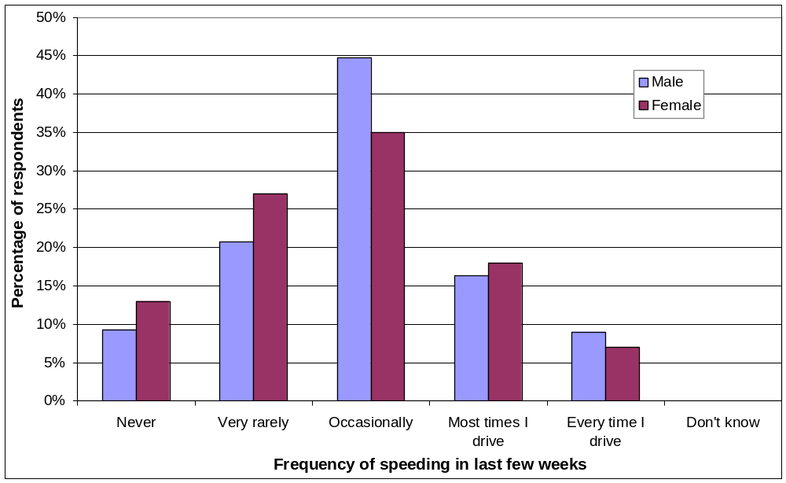
Figure 1 – Frequency of speeding by gender
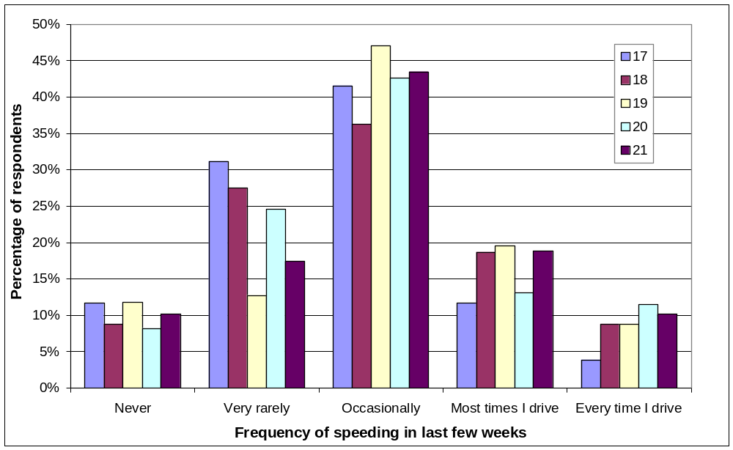
Figure 2 – Frequency of speeding by age
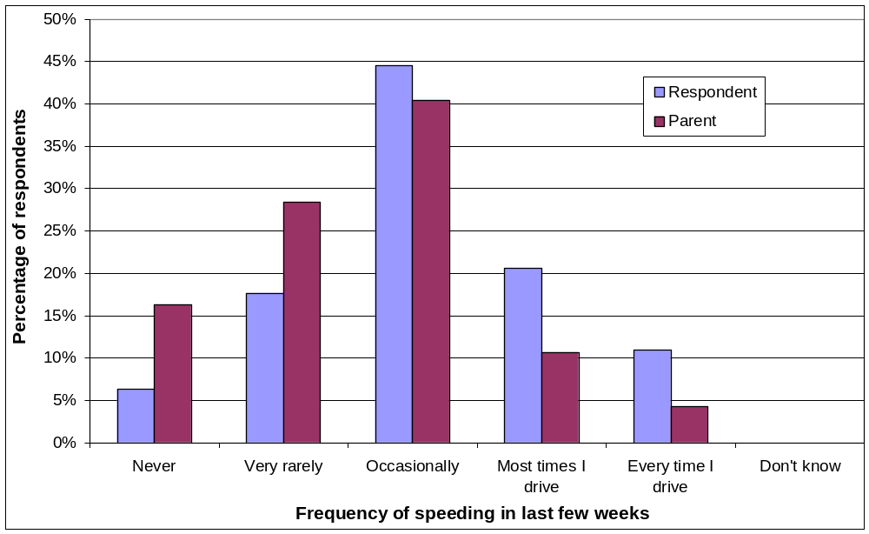
Figure 3 – Frequency of speeding by car ownership

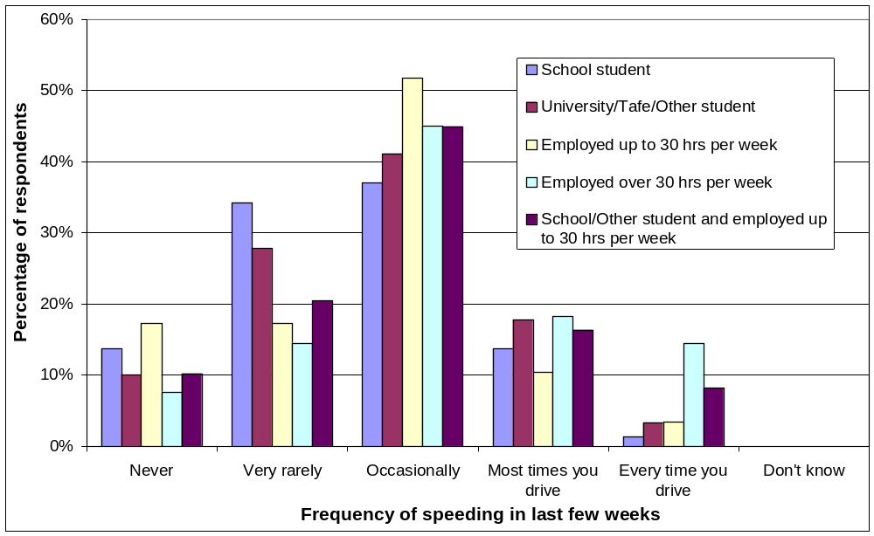
Figure 4 – Frequency of speeding by occupation

Mobile phone use
Table 15 and Figure 5 through Figure 8 show the frequency of using a mobile phone while driving by respondent age, respondent gender, ownership of the car typically driven by the respondent and respondent occupation.
Table 15 – Frequency of using a mobile phone while driving in the last few weeks
(% of respondents) by four demographic variables
 |  | Never | Very rarely | Occas-ionally | Most times I drive | Every time I drive | Total
GENDER | Male | 55.5 | 21.7 | 15.7 | 3.3 | 3.7 | 100.0
GENDER | Female | 65.0 | 19.0 | 12.0 | 3.0 | 1.0 | 100.0
AGE (years) | 17 | 61.0 | 20.8 | 14.3 | 1.3 | 2.6 | 100.0
AGE (years) | 18 | 56.0 | 25.3 | 11.0 | 5.5 | 2.2 | 100.0
AGE (years) | 19 | 56.9 | 21.6 | 15.7 | 2.9 | 2.9 | 100.0
AGE (years) | 20 | 67.2 | 16.4 | 11.5 | 1.6 | 3.3 | 100.0
AGE (years) | 21 | 50.0 | 19.1 | 22.1 | 4.4 | 4.4 | 100.0
OWNER of car most often driven | You | 51.1 | 23.2 | 18.1 | 3.4 | 4.2 | 100.0
OWNER of car most often driven | Your parent(s) | 71.6 | 16.3 | 9.2 | 2.1 | 0.7 | 100.0
OCCUPATION | School student | 59.2 | 26.3 | 11.8 | 1.3 | 1.3 | 100.0
OCCUPATION | Other student | 62.0 | 25.0 | 10.0 | 1.0 | 2.0 | 100.0
OCCUPATION | Employed up to 30 hrs per week | 55.2 | 27.6 | 10.3 | 3.4 | 3.4 | 100.0
OCCUPATION | Employed more than 30 hrs per week | 48.5 | 16.2 | 24.3 | 6.6 | 4.4 | 100.0
OCCUPATION | School/other student and employed up to 30 hrs per week | 78.4 | 13.7 | 5.9 | 2.0 | 0.0 | 100.0
Total |  | 57.9 | 21.1 | 14.8 | 3.3 | 3.0 | 100.0

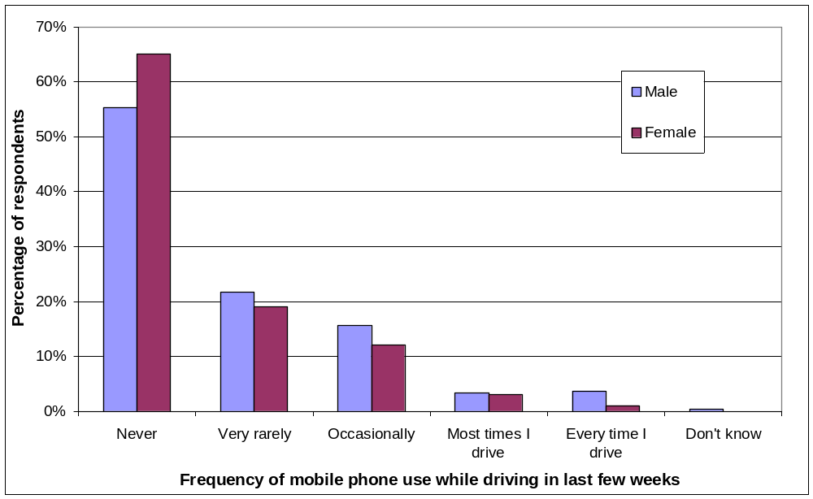
Figure 5 – Frequency of using a mobile phone while driving by gender
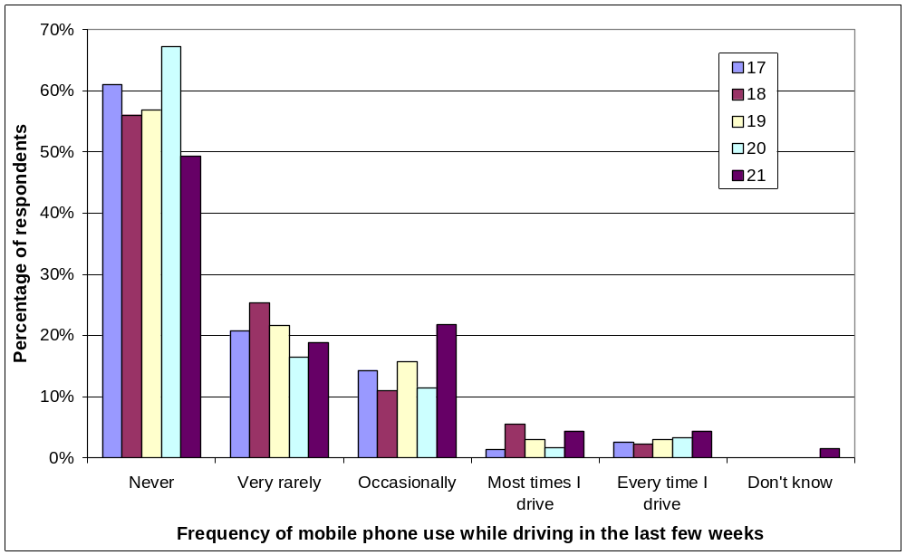
Figure 6 – Frequency of using a mobile phone while driving by age
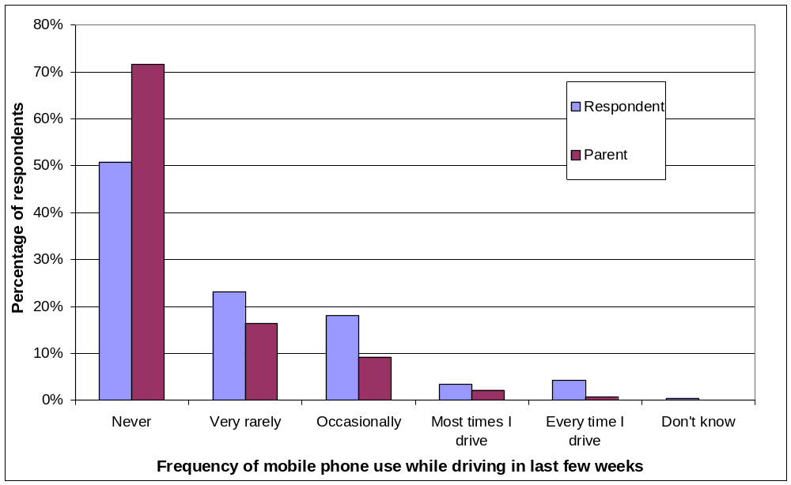
Figure 7 – Frequency of using a mobile phone while driving by car ownership
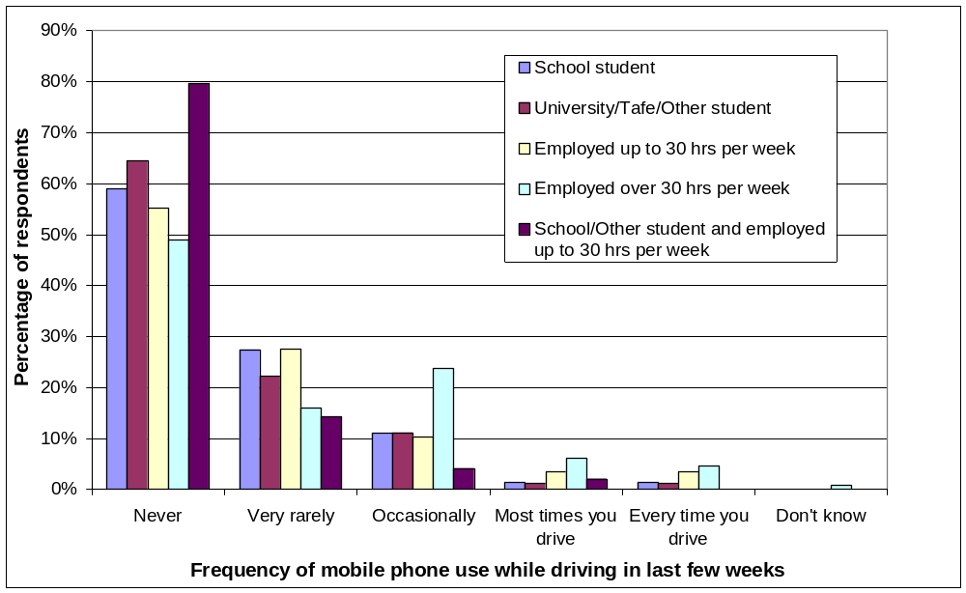
Figure 8 – Frequency of using a mobile phone while driving by occupation

Driving through red lights
Table 16 and Figure 9 through Figure 12 show the frequency of driving through a red light by respondent age, respondent gender, ownership of the car typically driven by the respondent and respondent occupation.
Table 16 – Frequency of driving through red lights in the last few weeks
(% of respondents) by four demographic variables
 |  | Never | Very rarely | Occasio-nally | Most times I drive | Every time I drive | Total
GENDER | Male | 84.7 | 9.3 | 3.7 | 1.7 | 0.7 | 100.0
GENDER | Female | 86.0 | 9.0 | 4.0 | 1.0 | 0.0 | 100.0
AGE (years) | 17 | 85.7 | 7.8 | 5.2 | 1.3 | 0.0 | 100.0
AGE (years) | 18 | 85.7 | 8.8 | 4.4 | 0.0 | 1.1 | 100.0
AGE (years) | 19 | 82.4 | 13.7 | 2.0 | 2.0 | 0.0 | 100.0
AGE (years) | 20 | 78.7 | 11.5 | 4.9 | 3.3 | 1.6 | 100.0
AGE (years) | 21 | 92.8 | 2.9 | 2.9 | 1.4 | 0.0 | 100.0
OWNER of car most often driven | You | 81.1 | 11.3 | 4.6 | 2.1 | 0.8 | 100.0
OWNER of car most often driven | Your parent(s) | 92.9 | 4.3 | 2.8 | 0.0 | 0.0 | 100.0
OCCUPATION | School student | 90.8 | 5.3 | 3.9 | 0.0 | 0.0 | 100.0
OCCUPATION | Other student | 84.0 | 11.0 | 3.0 | 1.0 | 1.0 | 100.0
OCCUPATION | Employed up to 30 hrs per week | 86.2 | 10.3 | 0.0 | 0.0 | 3.4 | 100.0
OCCUPATION | Employed more than 30 hrs per week | 81.0 | 11.7 | 5.1 | 2.2 | 0.0 | 100.0
OCCUPATION | School/other student and employed up to 30 hrs per week | 90.2 | 5.9 | 3.9 | 0.0 | 0.0 | 100.0
Total |  | 85.2 | 9.4 | 3.8 | 1.0 | 0.5 | 100.0

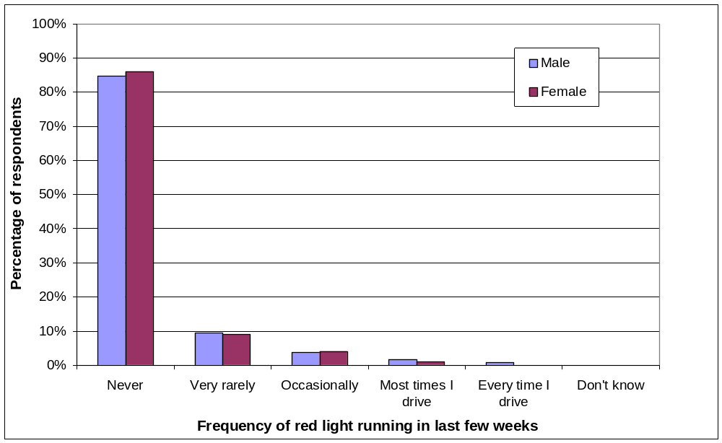
Figure 9 – Frequency of driving through red lights by gender
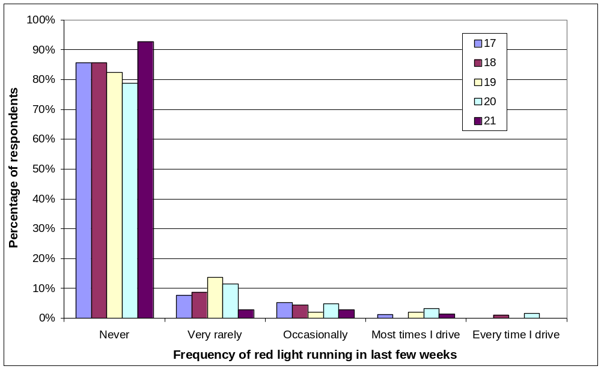
Figure 10 – Frequency of driving through red lights by age
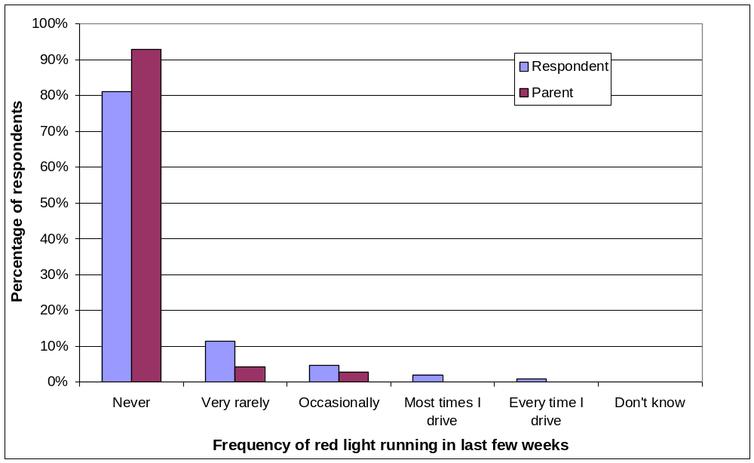
Figure 11 – Frequency of driving through red lights by car ownership
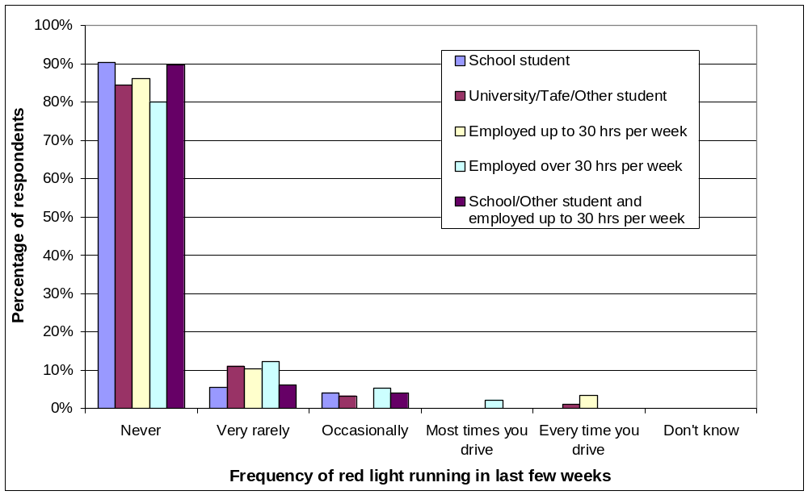
Figure 12 – Frequency of driving through red lights by occupation

Aggressive driving
Table 17 and Figure 13 through Figure 16 show the frequency of aggressive driving by respondent age, respondent gender, ownership of the car typically driven by the respondent and respondent occupation.
Table 17 – Frequency of aggressive driving in the last few weeks
(% of respondents) by four demographic variables
 |  | Never | Very rarely | Occas-ionally | Most times I drive | Every time I drive | Total
GENDER | Male | 48.0 | 31.0 | 17.7 | 2.3 | 1.0 | 100.0
GENDER | Female | 59.0 | 31.0 | 7.0 | 1.0 | 2.0 | 100.0
AGE (years) | 17 | 55.8 | 32.5 | 10.4 | 1.3 | 0.0 | 100.0
AGE (years) | 18 | 48.4 | 37.4 | 13.2 | 1.1 | 0.0 | 100.0
AGE (years) | 19 | 47.1 | 25.5 | 23.5 | 2.0 | 2.0 | 100.0
AGE (years) | 20 | 47.5 | 37.7 | 9.8 | 3.3 | 1.6 | 100.0
AGE (years) | 21 | 56.5 | 23.2 | 14.5 | 2.9 | 2.9 | 100.0
OWNER of car most often driven | You | 46.2 | 29.8 | 19.3 | 2.9 | 1.7 | 100.0
OWNER of car most often driven | Your parent(s) | 58.9 | 33.3 | 7.1 | 0.7 | 0.0 | 100.0
OCCUPATION | School student | 57.9 | 36.8 | 5.3 | 0.0 | 0.0 | 100.0
OCCUPATION | Other student | 53.0 | 31.0 | 12.0 | 3.0 | 1.0 | 100.0
OCCUPATION | Employed up to 30 hrs per week | 62.1 | 27.6 | 10.3 | 0.0 | 0.0 | 100.0
OCCUPATION | Employed more than 30 hrs per week | 45.3 | 26.3 | 24.1 | 3.6 | 0.7 | 100.0
OCCUPATION | School/other student and employed up to 30 hrs per week | 49.0 | 37.3 | 13.7 | 0.0 | 0.0 | 100.0
Total |  | 50.8 | 31.0 | 15.0 | 2.0 | 1.3 | 100.0

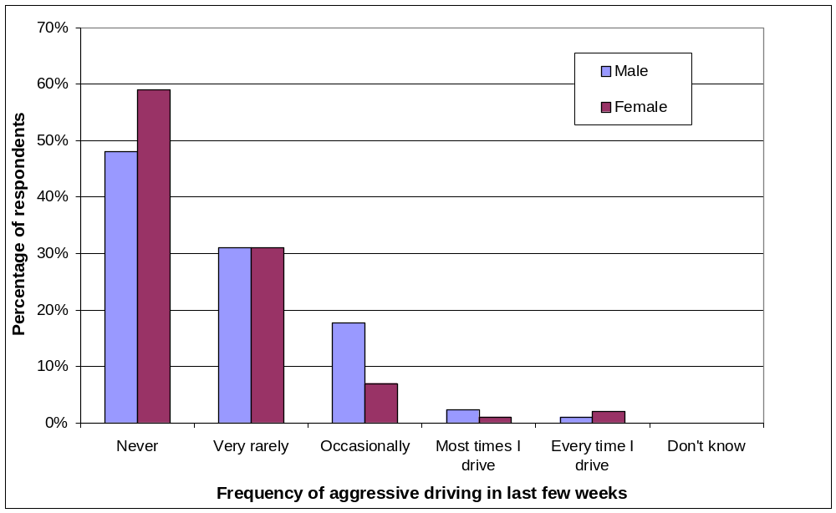
Figure 13 – Frequency of aggressive driving by gender
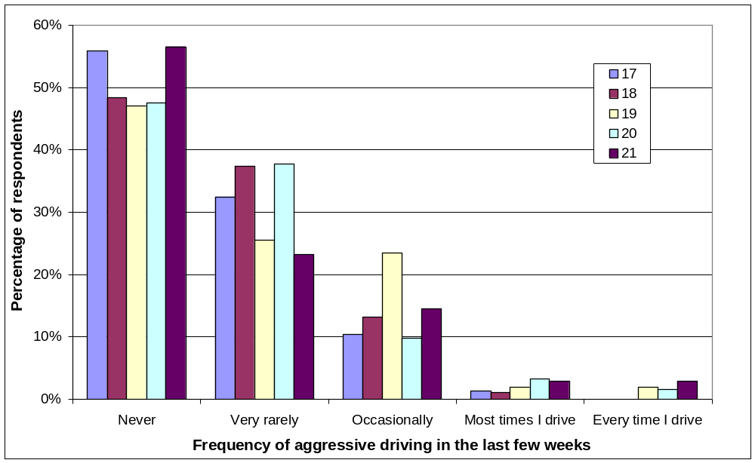
Figure 14 – Frequency of aggressive driving by age
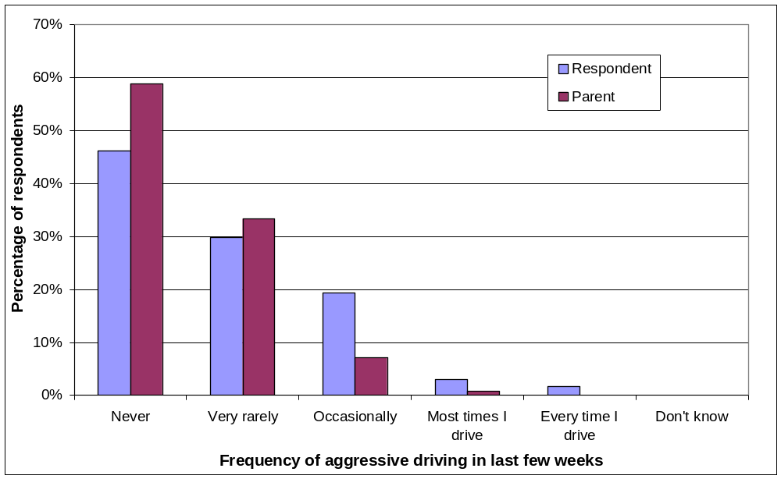
Figure 15 – Frequency of aggressive driving by car ownership
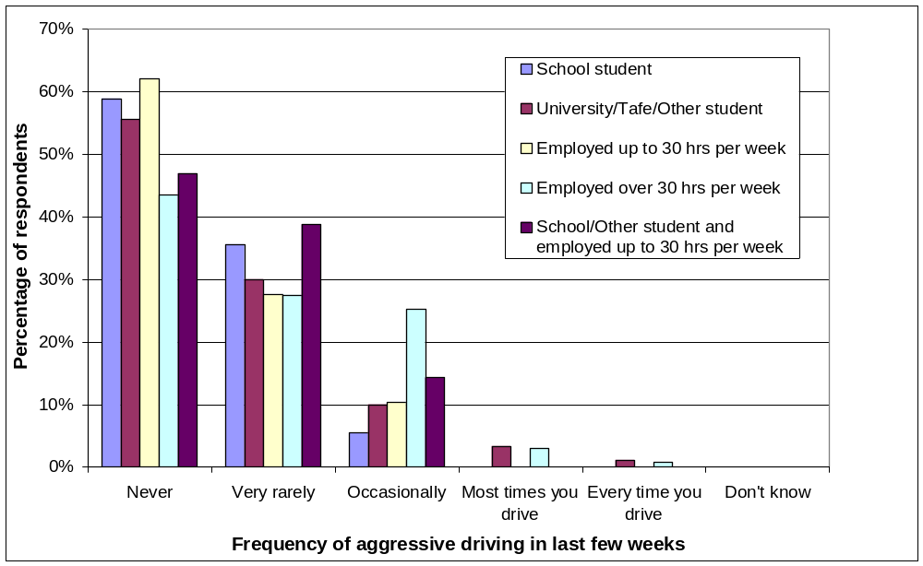
Figure 16 – Frequency of aggressive driving by occupation

Influence of parents

Perceived influence of parents
Table 18 shows that, among respondents who travelled in a car driven by their father at least once a month during the years before they began learning to drive, 49% of males and 53% of females felt their father’s driving had either a strong or very strong influence on their own driving. Table 18 also shows that, among respondents who travelled in the car while their mother was driving at least once a month during the years before they began learning to drive, 28% of males and 42% of females felt their mother’s driving had either a strong or very strong influence on their own driving.
Table 18 – Perceived influence of parents’ driving
 | Male |  | Female |  | Total
 | No. of respondents | % | No. of respondents | % | No. of respondents | %
FATHER
No influence at all | 30 | 11.0 | 6 | 7.1 | 36 | 10.1
Very little influence | 45 | 16.5 | 7 | 8.2 | 52 | 14.5
Moderate influence | 65 | 23.8 | 27 | 31.8 | 92 | 25.7
Strong influence | 71 | 26.0 | 19 | 22.4 | 90 | 25.1
Very strong influence | 62 | 22.7 | 26 | 30.6 | 88 | 24.6
Total | 273 | 100.0 | 85 | 100.0 | 358 | 100.0
MOTHER
No influence at all | 45 | 17.4 | 4 | 4.4 | 49 | 14.0
Very little influence | 70 | 27.0 | 16 | 17.8 | 86 | 24.6
Moderate influence | 72 | 27.8 | 32 | 35.6 | 104 | 29.8
Strong influence | 43 | 16.6 | 22 | 24.4 | 65 | 18.6
Very strong influence | 29 | 11.2 | 16 | 17.8 | 45 | 12.9
Total | 259 | 100.0 | 90 | 100.0 | 349 | 100.0

Risk-taking by parents
Respondents typically reported that their parents rarely or never engaged in some or all of the four risky behaviours investigated, as shown in Table 19.
Table 19 – Reported parental risk taking
 |  | Father |  | Mother
 |  | No. of respondents | % | No. of respondents | %
SPEEDING | Never | 135 | 37.7 | 210 | 60.2
SPEEDING | Very rarely | 101 | 28.2 | 80 | 22.9
SPEEDING | Occasionally | 78 | 21.8 | 44 | 12.6
SPEEDING | Most times he/she drove | 29 | 8.1 | 8 | 2.3
SPEEDING | Every time he/she drove | 7 | 2.0 | 3 | 0.9
SPEEDING | Don't know | 8 | 2.2 | 4 | 1.1
MOBILE PHONE USE | Never | 296 | 82.7 | 302 | 86.5
MOBILE PHONE USE | Very rarely | 29 | 8.1 | 35 | 10.0
MOBILE PHONE USE | Occasionally | 21 | 5.9 | 8 | 2.3
MOBILE PHONE USE | Most times he/she drove | 6 | 1.7 | 1 | 0.3
MOBILE PHONE USE | Every time he/she drove | 4 | 1.1 | 0 | 0.0
MOBILE PHONE USE | Don't know | 2 | 0.6 | 3 | 0.9
RED LIGHT RUNNING | Never | 312 | 87.2 | 319 | 91.4
RED LIGHT RUNNING | Very rarely | 28 | 7.8 | 25 | 7.2
RED LIGHT RUNNING | Occasionally | 12 | 3.4 | 5 | 1.4
RED LIGHT RUNNING | Most times he/she drove | 2 | 0.6 | 0 | 0.0
RED LIGHT RUNNING | Don't know | 4 | 1.1 | 0 | 0.0
AGGRESSIVE DRIVING | Never | 245 | 68.4 | 284 | 81.4
AGGRESSIVE DRIVING | Very rarely | 58 | 16.2 | 45 | 12.9
AGGRESSIVE DRIVING | Occasionally | 43 | 12.0 | 17 | 4.9
AGGRESSIVE DRIVING | Most times he/she drove | 10 | 2.8 | 2 | 0.6
AGGRESSIVE DRIVING | Every time he/she drove | 1 | 0.3 | 0 | 0.0
AGGRESSIVE DRIVING | Don't know | 1 | 0.3 | 1 | 0.3
TOTAL |  | 358 | 100.0 | 349 | 100.0

Association between risk-taking of respondent and parents
Cross-tabulations were performed to determine whether the self-reported frequency risk taking by the respondents was related to the frequency of the respondent’s mother or father performing the same risky behaviour. In order to minimise the number of empty cells in the tables, the reported frequency of each risky behaviour being performed by the respondent, the respondent’s mother and the respondent’s father were all transformed to dichotomous variables. Each variable was dichotomised in such a way as to create as near as possible to a 50–50 balance between the group performing the behaviour more often and the group performing the behaviour less often.
Statistical tests were conducted to assess the reliability of the associations revealed by the cross-tabulations. Some expected cell frequencies were less than five, so Fisher’s exact test was used to evaluate the statistical significance of the results rather than the chi-square test. Fisher’s exact test is unaffected by small sample sizes and is almost always more conservative than the chi-square test. Table 20 presents the results of these tests.
Table 20 – Tests of association between parental risk taking and respondent risk taking
(* indicates statistically significant test results)
Relationship tested | Gender of respondent | Significance
Mother’s speeding and self-reported speeding | Males | p = .390
Mother’s speeding and self-reported speeding | Females | p = .480
Father’s speeding and self-reported speeding | Males | p = .010*
Father’s speeding and self-reported speeding | Females | p = .660
Mother’s mobile phone use and self reported mobile phone use | Males | p = .049*
Mother’s mobile phone use and self reported mobile phone use | Females | p = .760
Father’s mobile phone use and self reported mobile phone use | Males | p = .180
Father’s mobile phone use and self reported mobile phone use | Females | p = .780
Mother’s red light running and self reported red light running | Males | p = .025*
 | Females | p = .002*
Father’s red light running and self reported red light running | Males | p = .001*
 | Females | p = .002*
Mother’s aggressive driving and self reported aggressive driving | Males | p = .006*
 | Females | p = .128
Father’s aggressive driving and self reported aggressive driving | Males | p = .000*
 | Females | p = .005*

Table 20 shows that among males, driving through red lights and aggressive driving are related to the behaviour of both parents; speeding is associated with speeding by the father; and mobile phone use is associated with mobile phone use by the respondent’s mother. Among females, driving through red lights is associated with the behaviour of both parents and aggressive driving is linked to the father’s behaviour.
It should be noted that some of the low cell frequencies in the above analyses required the use of Fisher’s exact test, which is a conservative procedure. The use of a larger sample, which would allow the use of the chi-square test, may identify significant associations that were not evident in the above analyses.
For those relationships that were shown to be statistically significant, calculation of odds ratios revealed the following:
- Male respondents whose father was seen to speed at least occasionally were 2.3 times more likely than other male respondents to speed at least occasionally.
- Male respondents whose father was seen to run red lights at least rarely were 4.3 times more likely than other male respondents to run red lights at least rarely.
- Male respondents whose father was seen to drive aggressively at least rarely were 2.7 times more likely than other male respondents to drive aggressively at least rarely.
- Male respondents whose mother was seen to use a mobile phone at least rarely were 2.1 times more likely than other male respondents to use a mobile phone while driving at least rarely.
- Male respondents whose mother was seen to run red lights at least rarely were 4.2 times more likely than other male respondents to run red lights at least rarely.
- Male respondents whose mother was seen to drive aggressively at least rarely were 2.6 times more likely than other male respondents to drive aggressively at least rarely.
- Female respondents whose father was seen to run red lights at least rarely were 9.8 times more likely than other female respondents to run red lights at least rarely.
- Female respondents whose father was seen to drive aggressively at least rarely were 4.0 times more likely than other female respondents to drive aggressively at least rarely.
- Female respondents whose mother was seen to run red lights at least rarely were 7.8 times more likely than other female respondents to run red lights at least rarely.
Whilst the driving behaviour of parents appears to influence risk-taking by respondents, it is by no means the sole determinant. For example, although speeding is significantly more common among males whose father speeds than among males whose father does not speed, there were still far more male speeders whose father does not speed than male speeders whose father speeds. Clearly, there are other influences at work. The next section examines the effect of some other factors that may influence risky behaviour.

Influence of gender, age, experience and over-confidence
A series of logistic regressions was conducted to determine the effect of gender, age, driving experience, confidence, expectation of adverse consequences and experience of adverse consequences on the frequency of risky driving behaviour. As in the previous section, the four variables indicating the frequency of the four risky driving behaviours were converted to dichotomous form in such a way as to achieve as near as possible to a 50–50 balance between the high frequency and low frequency groups. The predictor variables were:
- Gender
- Age: whole years
- Experience (continuous): two measures of experience were trialled. The first was simply the number of months since the respondent obtained his or her provisional licence. The second was the product of the number of months for which a licence had been held, the self-reported average number of hours travelled in a week and 4.3 (the number of weeks in a month). Thus, this second measure of experience was essentially a rough estimate of the number of hours the respondent had spent driving since obtaining his or her provisional licence. It is recognised that the number of hours travelled in an average week is likely to have changed since respondents gained their licence. As such, this measure of experience is not assumed to be highly accurate, but rather an index of time spent actually driving, as compared to time having held a licence. The two measures of experience were moderately correlated (Pearson’s r² = .38).
- Self reported driving skill: a dichotomous variable was created from self-reports of driving skill which had five response options (Appendix A, Question 16). Those who reported being much more skilful or a little more skilful than other drivers of their age and gender were classified as ‘more skilful’ (59% of males and 53% of females). Those who reported being about the same, a little less skilful or much less skilful were classified as ‘the same or less skilful’ (41% of males and 47% of females).
- Self reported driving safety: a dichotomous variable was created from self-reports of driving safety which had five response options (Appendix A, Question 17). Those who reported being much more safe or a little more safe than other drivers of their age and gender were classified as ‘more safe’ (70% of males and 59% of females). Those who reported being about the same, a little less safe or much less safe were classified as ‘the same or less safe’ (30% of males and 41% of females).
- Respondent estimates of the impact of each behaviour on the risk of being involved in an accident (Appendix A, Questions 22, 29 and 36): these variables were dichotomised to achieve roughly a 50/50 split between higher and lower estimates. The exact nature of this split differed for each behaviour.
- Respondent estimates of the impact of the behaviour on the risk of being fined by police (Appendix A, Questions 24, 31 and 38): these variables were dichotomised to achieve roughly a 50/50 split between higher and lower estimates. The exact nature of this split differed for each behaviour.
- Whether or not the respondent had ever had an accident due to the relevant risky driving behaviour (Appendix A, Questions 23, 30 and 37): dichotomous.
- Whether or not the respondent had ever been fined by police after the relevant risky driving behaviour (Appendix A, Questions 25, 32 and 39): dichotomous.
The proportion of males and females in each category associated with the latter four variables described above is presented in Table 21. Aggressive driving is not included in Table 21 because respondents were not asked to report on their opinions of the risk of crashing and fines associated with aggressive driving, nor on their experiences of crashing or being fined as a result of aggressive driving.
Table 21 – Number of participants in response categories for estimated risk
and experienced outcomes for each risky behaviour
 |  | Male |  | Female |  | Total
 |  | No. of respondents | % | No. of respondents | % | No. of respondents | %
SPEEDING
Estimated crash risk | Higher | 107 | 36.4 | 60 | 61.2 | 167 | 42.3
Estimated crash risk | Lower | 190 | 63.6 | 38 | 38.8 | 228 | 57.7
Estimated fine risk | Higher | 110 | 37.2 | 42 | 43.9 | 152 | 38.6
Estimated fine risk | Lower | 186 | 62.8 | 56 | 56.1 | 242 | 61.4
Experienced crash? | Yes | 19 | 7.0 | 2 | 2.3 | 21 | 5.8
Experienced crash? | No | 253 | 93.0 | 85 | 97.7 | 338 | 94.2
Been fined? | Yes | 111 | 40.8 | 21 | 24.1 | 132 | 36.8
Been fined? | No | 161 | 59.2 | 66 | 75.9 | 227 | 63.2
USING A MOBILE PHONE
Estimated crash risk | Higher | 162 | 54.2 | 74 | 74.0 | 236 | 59.1
Estimated crash risk | Lower | 137 | 45.8 | 26 | 26.0 | 163 | 40.9
Estimated fine risk | Higher | 136 | 45.5 | 46 | 46.9 | 182 | 45.8
Estimated fine risk | Lower | 163 | 54.5 | 52 | 53.1 | 215 | 54.2
Experienced crash? | Yes | 1 | 0.7 | 1 | 2.9 | 2 | 1.2
Experienced crash? | No | 133 | 99.3 | 34 | 97.1 | 167 | 98.8
Been fined? | Yes | 2 | 0.5 | 0 | 0.0 | 2 | 1.2
Been fined? | No | 132 | 98.5 | 35 | 100.0 | 167 | 98.8
RED LIGHT RUNNING
Estimated crash risk | Higher | 240 | 80.3 | 80 | 80.0 | 320 | 80.2
Estimated crash risk | Lower | 59 | 19.7 | 20 | 20.0 | 79 | 19.8
Estimated fine risk | Higher | 156 | 52.9 | 59 | 59.0 | 215 | 54.4
Estimated fine risk | Lower | 139 | 47.1 | 41 | 41.0 | 180 | 45.6
Experienced crash? | Yes | 2 | 4.3 | 0 | 0.0 | 2 | 3.3
Experienced crash? | No | 44 | 96.7 | 14 | 100.0 | 58 | 96.7
Been fined? | Yes | 5 | 11.1 | 1 | 7.1 | 6 | 10.0
Been fined? | No | 41 | 88.9 | 13 | 92.9 | 54 | 90.0
Note: Only participants who reported having engaged in a particular behaviour in the last few weeks were asked to provide information about associated adverse consequences.

Speeding
Those who believed that speeding greatly increases the chance of being involved in an accident (42%) comprised the ‘higher estimated crash risk’ group and those who reported that speeding slightly increases, makes no difference to, or decreases the risk of being involved in an accident comprised the ‘lower estimated crash risk’ group (58%). Those who believed that speeding is likely or very likely to result in a fine (39%) comprised the ‘higher estimated fine risk’ group and those who reported that speeding is moderately likely, unlikely or very unlikely to result in a fine comprised the ‘lower estimated risk’ group (61%).
A logistic regression analysis using the forward stepwise method was performed on frequency of speeding (higher versus lower) as the outcome variable and the variables listed in Section 2.2.7 (including months of driving as a measure of experience) as predictor variables. Data from 259 males and 82 females were available for analysis. The model produced included driving experience, whether the respondent had been fined or not and self reported driving safety as predictor variables. This model was statistically reliable χ² (3, N = 341) = 32.033, p = .000. The associated coefficients indicated that those who have more experience, those have been fined for speeding and those who rate themselves as less safe are more likely to report speeding more frequently. The variance in speeding frequency accounted for by the model was 9%.
When the second measure of experience (estimated hours spent driving) was employed as a predictor variable, a forward stepwise logistic regression analysis was performed on speeding frequency (higher versus lower) as the outcome variable. Data from 247 males and 81 females were available for analysis. The model produced included whether or not the individual had been fined and self reported driving safety as predictor variables. This model was statistically reliable χ² (2, N = 328) = 20.923, p = .000. The coefficients associated with the significant predictor variables indicate that those who rate themselves as less safe drivers and who have been fined for speeding are more likely to be included in the higher frequency group. The inclusion of the same variables in this model as were included when the other measure of experience was used lends support to their value as predictors of frequency of speeding. The exclusion of the second measure of experience from this latter model lends further support to the notion that this measure is not as useful as the number of months for which a provisional licence has been held in predicting speeding. The variance in speeding frequency accounted for by this second model was 6%.
A forward stepwise logistic regression analysis was performed on change in speeding frequency (increase versus no increase) as the outcome variable and the predictor variables listed in Section 2.2.7. Data from 259 males and 82 females were available for analysis. The resulting model included gender and experience of being fined as significant predictor variables. This model was statistically reliable χ² (2, N = 341) = 18.53, p = .000, indicating that gender and whether or not a young driver has been fined for speeding reliably distinguished between those who had increased speeding and those who had not although the variance accounted for was relatively small (5.3%). The coefficients obtained for the predictor variables indicated that females and those who have not been fined for speeding are more likely to have increased the frequency of speeding since they obtained a provisional licence.
When the second measure of experience (estimated hours spent driving) was employed as a predictor variable, a forward stepwise logistic regression analysis was performed on change in speeding frequency (increase versus no increase) as the outcome variable. Data from 247 males and 81 females were available for analysis. The resulting model included only gender as a predictor variable. This model was statistically reliable χ² (1, N = 328) = 14.531, p = .000. The variance in speeding frequency accounted for was small, however (4.3%). It is interesting to note that being fined was not included in this second model. This is most likely due to the fact that the sample available for this second analysis was different from that available for the first.

Mobile phone use
Those who believed that using a mobile phone while driving greatly increases the chance of being involved in a crash (59%) comprised the ‘higher estimated crash risk’ group and those who reported that using a mobile phone while driving slightly increases, makes no difference to or decreases the risk of being involved in an accident comprised the ‘lower estimated crash risk’ group (41%). Those who believed that using a mobile phone while driving is moderately likely, likely or very likely to result in a fine (46%) comprised the ‘higher estimated fine risk’ group and those who reported that using a mobile phone while driving is unlikely or very unlikely to result in a fine comprised the ‘lower estimated risk’ group (54%).
A forward stepwise logistic regression was performed on frequency of using a mobile phone while driving (higher versus lower) as the outcome variable and the prediction variables listed Section 2.2.7, including months held a licence as the experience variable. Data from 131 males and 35 females were available for analysis. None of the predictor variables was shown to reliably distinguish between the ‘higher frequency’ and the ‘lower frequency’ groups, so no model was constructed. This indicates that gender age, experience, the measures of confidence employed and the measures of adverse consequences employed do not reliably distinguish those who use a mobile phone more frequently while driving from those who do so less frequently. When the second measure of experience (estimated hours spent driving) was employed as a predictor variable using data from 124 males and 34 females, no predictors were shown to be statistically significant.
A second pair of forward stepwise logistic regressions were performed on change in frequency of using a mobile phone while driving (increase versus no increase) as the outcome variable and the predictor variables listed in Section 2.2.7. With reported months for which a licence had been held used as a measure of driving experience, data from 129 males and 35 females were available for analysis. Because none of the predictor variables reliably predicted change in mobile phone use, no model was created. This indicates that none of the predictor variables employed (gender age, experience, the measures of confidence and the measures of adverse consequences) reliably distinguishes between those who have increased their mobile phone use and those who have not. No model was constructed when the second measure of experience (estimated hours spent driving) was employed using data from 122 males and 34 females.

Driving through red lights
Those who believed that driving through a red light greatly increases the chance of being involved in an accident (80%) comprised the ‘higher estimated crash risk’ group and those who reported that driving through a red light slightly increases, makes no difference to or decreases the risk of being involved in an accident comprised the ‘lower estimated crash risk’ group (20%). Those who believed that driving through a red light is likely or very likely to result in a fine (54%) comprised the ‘higher estimated fine risk’ group and those who reported that driving through a red light is moderately likely or unlikely or very unlikely to result in a fine comprised the ‘lower estimated risk’ group (46%).
It was not possible to conduct logistic regressions on frequency of driving through a red light because no respondents who drive through red lights responded to questions pertaining to all predictor variables.
A forward stepwise logistic regression was performed on change in frequency of driving through red lights (increase versus no increase) as the outcome variable and the predictor variables listed in Section 2.2.7. Data from 45 males and 12 females were available for analysis. Because none of the predictor variables reliably predicted changes in this behaviour, no model was created. In the very small sample of cases available for this analysis, none of the predictor variables employed (gender age, experience, the measures of confidence and the measures of adverse consequences) reliably distinguishes between those who have increased the frequency with which they drive through red lights and those who have not. No model was constructed when the second measure of experience (estimated hours spent driving) was employed. This analysis was conducted with data from 41 males and 11 females.

Aggressive driving
As mentioned above, respondents were not asked to report on their opinions of the risk of crashing and fines associated with aggressive driving, nor on their experiences of crashing or being fined as a result of aggressive driving. As such only the two confidence variables were included in the logistic regressions described below.
A logistic regression analysis using the forward stepwise method was performed on frequency of aggressive driving (higher versus lower) as the outcome variable and the predictor variables used in the regression described above. Data from 292 males and 96 females were available for analysis. The resulting model included gender and driving safety as significant predictor variables. This model was statistically reliable χ² (2, N = 388) = 12.322, p = .002, indicating that gender and whether or not a young driver thinks he or she is safer than other drivers reliably distinguished between those who drive aggressively more frequently and those who drive aggressively less frequently. The variance accounted for was small, however (3.1%). The coefficients obtained for the predictor variables included in the model indicated that males and those who think they are less safe are more likely to have a higher frequency of aggressive driving.
Interestingly, when self-reported safety is removed from the logistic regression, gender is no longer a significant predictor of aggressive driving. This indicates that gender is shown to be a predictor of aggressive driving purely through its correlation with self-reported safety as a driver. Through this correlation, gender suppresses some of the variance in driving safety that is not relevant to predicting aggressive driving. As such, the presence of gender in the logistic regression model actually increases the statistical significance of driving safety as a predictor.
When the second measure of experience (estimated hours spent driving) was employed as a predictor variable, a forward stepwise logistic regression analysis was performed on frequency of aggressive driving (higher versus lower) as the outcome variable. Data from 277 males and 93 females were available for analysis. The model produced included driving experience and driving safety as predictor variables. This model was statistically reliable χ² (2, N = 370) = 11.567, p = .003, indicating that experience (estimated hours driving) and whether or not a young driver thinks he or she is safer than other drivers reliably distinguished between those who had increased their aggressive driving and those who had not. The variance in aggressive driving frequency accounted for was small, however (3.1%). The coefficients obtained for both predictor variables indicated that those with more experience and that those who think they are less safe are more likely to report a higher frequency of aggressive driving.
A forward stepwise logistic regression was performed on change in frequency of aggressive driving (increase versus no increase) as the outcome variable and age, gender, experience (months holding a licence) and the two confidence variables as predictor variables. Data from 292 males and 96 females were available for analysis. None of the predictor variables was shown to reliably distinguish between the ‘increase’ and the ‘no increase’ groups, so no model was constructed. This indicates that gender age, experience, the measures of confidence employed do not reliably distinguish between those who have increased the frequency with which they drive aggressively and those who have not. When the second measure of experience (estimated hours spent driving) was employed as a predictor variable using data from 277 males and 93 females, no predictors were shown to be statistically significant.

Summary

Prevalence of risk-taking among ACT novice drivers
The most frequently reported risky behaviour was speeding: 90% of respondents admitted to some speeding within the last few weeks and 25% reported that they speed most times or every time they drive. Driving aggressively and using a hand-held mobile phone while driving were reported to be much less frequent, with 51% and 58% of drivers respectively stating that they had not engaged in these behaviours at all in the last few weeks. Red light running was the least frequent of the four risky behaviours, with 85% of respondents reporting that they had not run any red lights in the last few weeks.

Reasons for risky driving
Most of the reasons offered by respondents for speeding, using a mobile phone while driving and running red lights implied that the respondent received some benefit as a result of the behaviour. For example, being in a hurry was the most frequently reported reason for speeding and for running red lights; the importance of the calls made or received was often mentioned as part of the reason for using a mobile phone while driving. The next most frequently reported group of reasons for engaging in these three behaviours carried implications of over-confidence, including references to there being no other cars around, being familiar with the road, being a good enough driver and speed limits being set too low.
The reported motivations for aggressive driving differed markedly from those for the other three risky behaviours. Aggressive driving was most often blamed on the behaviour of other drivers, with only a small minority of respondents implying that any benefit was obtained from aggressive driving and no respondents citing reasons directly related to confidence.
None of the reasons reported by respondents for any of the four risky behaviours indicated that the formation of habits was partly responsible for risk-taking. Whilst this result does not rule out some contribution by habit, it does suggest that respondents are not aware of any such influence.

Demographic factors
Not surprisingly, the self-reported frequency of speeding, using a mobile phone while driving, and driving aggressively was higher for males than for females. There was little apparent difference between males and females in relation to driving through red lights and most people reported that they never engage in this behaviour. There was no obvious relationship between age and the frequency of the risky behaviours measured. It appeared that respondents who usually drove their own car tended to engage in all four risky behaviours more frequently than those who typically drove a parent’s car. Respondents who were employed over 30 hours per week reported that they engage in each of the four risky behaviours more frequently than those in the other occupation categories.

Influence of parents’ driving style
The majority of respondents considered that their own driving was influenced by the driving style of their father and mother. Female respondents were more likely than male respondents to report being influenced by the driving styles of their parents. Both male and female respondents reported greater levels of influence by their father’s driving style than by their mother’s driving style.
Reported levels of risk-taking by respondents’ parents were lower than self-reported levels of risk-taking by respondents themselves. Fathers were reported to engage in higher levels of risk-taking than were mothers. For both fathers and mothers, the frequency ranking of the four risky behaviours was similar to the frequency ranking for respondents: speeding was the most commonly reported, followed by aggressive driving and mobile phone use, with red light running being the least often reported.
When respondents were asked about their perception of the influence of their parents’ driving style on their own, female respondents were more likely than male respondents to report being influenced by their parents. However, when self-reported risk-taking was compared with the risk-taking of respondents’ parents, the opposite pattern emerged: the associations between risk-taking by respondents and their parents were stronger for male respondents than for female respondents. The frequency of risky behaviour by male respondents was found to be significantly associated with the frequency of the same behaviour by their fathers for three out of four risky behaviours (speeding, red light running and aggressive driving but not mobile phone use) and significantly associated with the frequency of the same behaviour by their mothers also for three out of four behaviours (mobile phone use, red light running and aggressive driving but not speeding). In contrast, the frequency of risky behaviour by female respondents was found to be significantly associated with the frequency of the same behaviour by their fathers for only two behaviours (red light running and aggressive driving) and with the frequency of the same behaviour by their mothers for only one behaviour (red light running). All significant associations were positive: higher levels of risk-taking by the parents were associated with higher levels of risk-taking by the respondent. The driving style of mothers appeared to be almost as influential as that of fathers, with five out of eight comparisons involving fathers’ behaviour and four out of eight comparisons involving mothers’ behaviour revealing statistically significant associations.
Despite the statistically significant association between speeding by male respondents and speeding by their fathers, it is worth noting that there were still far more male speeders whose father does not speed than male speeders whose father speeds.

Influence of gender, age, experience and over-confidence
Table 22 summarises the results of the logistic regressions that were conducted to assess the influence of gender, age, driving experience, confidence, expectation of adverse consequences and experience of adverse consequences on the frequency of engaging in each of the four risky driving behaviours and on changes in the frequency of each behaviour since obtaining a provisional licence.
Table 22 – Summary of predictors of risk taking behaviours
Outcome | Associated factors | Variance accounted for
More frequent speeding | Held a solo licence for longer AND having been fined for speeding AND do not report being safer than other drivers of their age and gender | 9.0%
Increasing speeding | Being female AND not having been fined for speeding | 5.3%
More frequent mobile phone use while driving | None | -
Increasing mobile phone use | None | -
More frequent red light running | Not assessed | -
Increasing red light running | None | -
More frequent aggressive driving | Being male AND not reporting being safer than other drivers the same age and gender  OR  Having more hours driving total experience AND not reporting being safer than other drivers the same age and gender | 3.1%  3.1%
Increasing aggressive driving | None | -

Traffic offences

Method

Data source and preparation
Information about all traffic offences committed by drivers first licensed during the period January 1994 to December 2004 was supplied by the Rego.ACT section of the ACT Department of Urban Services. Unfortunately, very little information was received concerning drink-driving offences, as in most cases drink-driving does not result in the recording of an offence but is recorded elsewhere in the ACT licensing system. Only 0.04% of offence records received were for drink-driving offences.
Details of the data received from Rego.ACT and the preparation of the data for analysis can be found in Appendix B.

Risky and non-risky offences
Traffic offence data were used as an indication of risk-taking. It was therefore necessary to distinguish between offences that increase the risk of accident or injury and those that do not. This distinction cannot be made perfectly, since a given offence may be much more risky in some circumstances than in others. The following broad generalisations were made:
- Offences were classified as risky if they involved speeding, alcohol, running a red or yellow traffic signal, using a hand-held phone while driving, failing to wear a seat belt, careless or negligent driving, failing to give way, failing to signal, unaccompanied driving by a learner, wrong way driving, improper turns, improper overtaking, driving without headlights at night, carrying unrestrained passengers, burnouts or street racing.
- Apart from certain specific exceptions, offences were classified as non-risky if they involved unauthorised parking/stopping/standing, vehicle defects, vehicle administrative offences (e.g. unregistered), failure to produce a licence, driving unlicensed, driving while suspended, failing to display P or L plates, disobeying a sign, not stopping at or before a stop line or exceeding maximum vehicle dimensions.
- Parking/stopping/standing offences were classified as risky if the offence description included the term ‘dangerous’.
- Disobeying a ‘no overtaking’ or ‘no exit’ sign was classified as risky.

Driver and offence selection
Drivers were included in the analysis only if they obtained their first ACT learner car licence and their first ACT provisional car licence during the period 1/1/1994 to 8/12/2004, inclusive. Drivers were excluded if they held any form of motorcycle licence before the issue of their provisional car licence, since previous experience of riding a motorcycle may have influenced their subsequent behaviour as a car driver. Drivers were also excluded if they held a provisional licence for less than three years before being issued a full licence, as this indicated they may have held a previous licence in the ACT or another jurisdiction.
The following offences were excluded from the analysis:
- non-risky offences, as described in Section 3.1.2
- offences committed by passengers or pedestrians rather than drivers
- offences that relate specifically to bicycles, motorcycles or heavy vehicles, rather than passenger cars
- offences committed before the driver was issued with a learner permit
- offences committed by drivers excluded from the analysis, as described in the previous paragraph.
Following all exclusions, 43 542 drivers and 44 707 offences remained in the analyses.

Calculation of offence rates
The offence rate for each demographic group within the ACT driving population was defined as the number of risky offences committed by drivers belonging to the group divided by the opportunity for members of the group to commit offences. The opportunity to commit offences was defined as the number of days spent as a member of that group summed over all eligible licence holders.
The calculation of offence rates is best illustrated by an example. The number of eligible offences committed by 18 year old drivers was 6332. The opportunity for each driver to commit an offence as an 18 year old is the elapsed time (in days) from when the driver obtained a provisional licence or turned 18 (whichever is the later) until the driver turned 19 or the end of the study period (8/12/2004) (whichever is the earlier). The sum of the time spent as an 18 year old holding a solo licence across all eligible drivers was 8 680 574 days. The offence rate for 18 year olds was therefore 6332 offences divided by 8 680 574 licence days, which equals 72.9 offences per 100 000 licence days or 266.4 offences per thousand licence holders per year.

Results
Except in Section 3.2.3, the offence rates reported in this section apply to holders of provisional and full ACT car driver licences. Holders of learner licences have been excluded from all other breakdowns.

Gender and age
The rate of risky offences per thousand drivers per year is shown as a function of driver age and gender in Figure 17. The chart shows that the offence rate for males is much higher than that for females at all ages. The overall offence rate across all ages for males was 309.8 offences per thousand licence holders per year, just over double the overall rate of 145.7 offences per thousand licence holders per year for females. For males, the offence rate drops steeply with increasing age from age 17 onwards, whereas for females there is little change in offence rate until at least age 22 years.
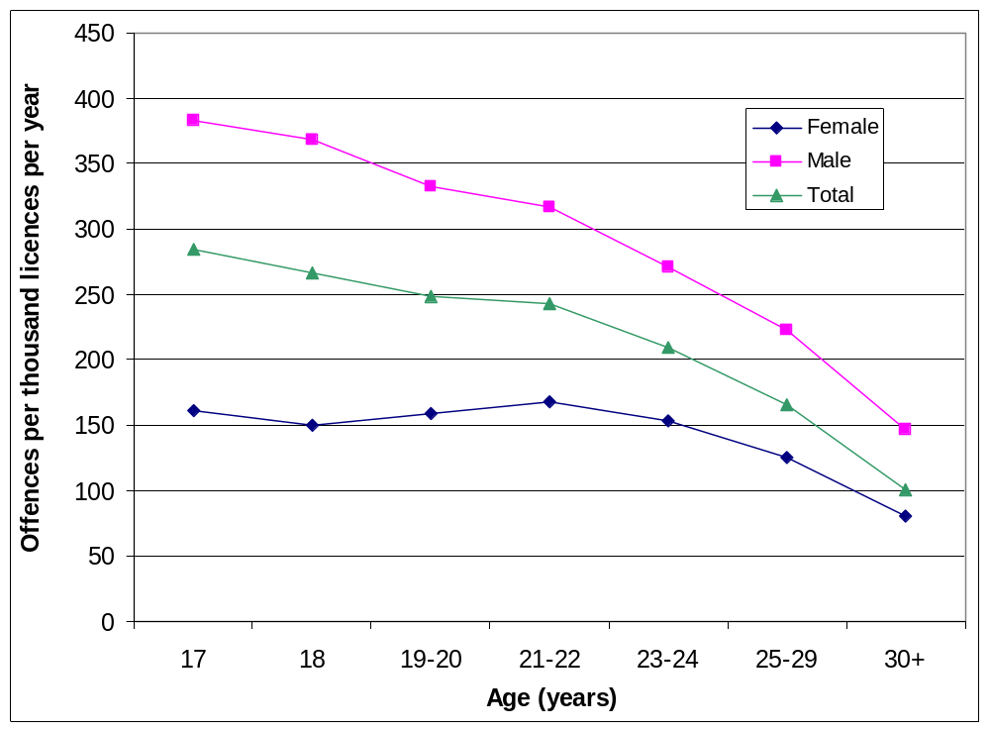
Figure 17 – Offence rate by driver age and gender

Experience
Driving experience was defined as the number of months since the driver obtained their first provisional licence. The offence rate for male and female drivers is shown as a function of driving experience in Figure 18. The offence rate for males begins to drop from about 6 months driving experience onwards, whereas the rate for females does not decrease until at least 6–8 years of driving experience have been accumulated. For both males and females, there is an increase in the rate of traffic offences after three years of experience—that is, at about the time of graduating from a provisional licence to a full licence.
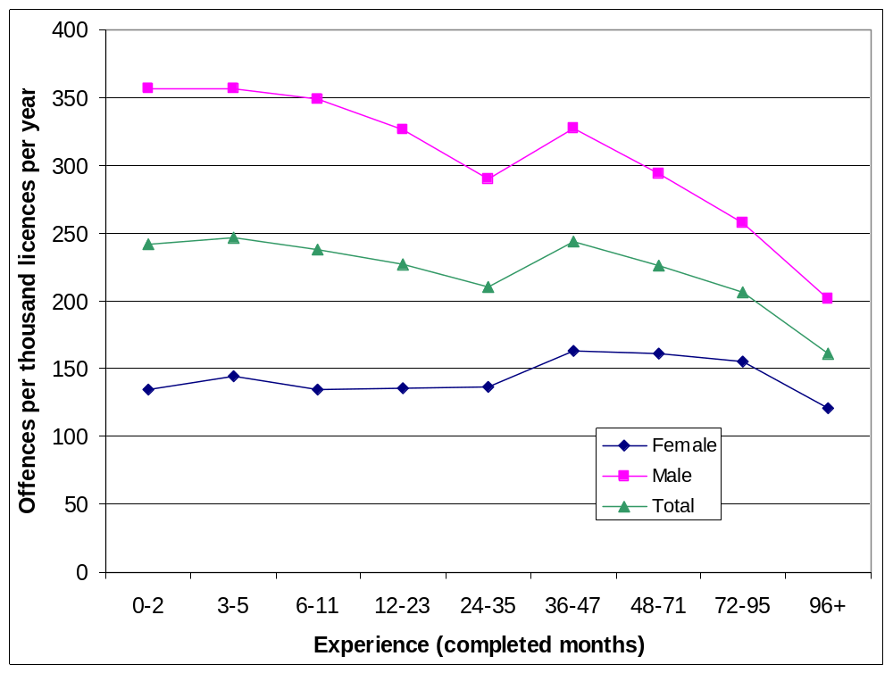
Figure 18 – Offence rate by driving experience and gender
In order to assess the separate effects of age and experience on risk-taking, offence rates were examined as a function of age for drivers in different experience groups (Figure 19) and as a function of experience for drivers in different age groups (Figure 21). When driving experience is controlled, Figure 19 shows that offence rates fall steeply with increasing age. Figure 20 is a simplified version of Figure 19 in which driving experience has been classified as the first three years versus the fourth and subsequent years. Offence rates are clearly higher for drivers with at least three years experience than for those of the same age with less than three years experience. Within both experience groups, offence rates fall rapidly with increasing age. Figure 21 reveals that for most age groups the offence rate is fairly flat for the first three years, before rising steeply for the next several years.
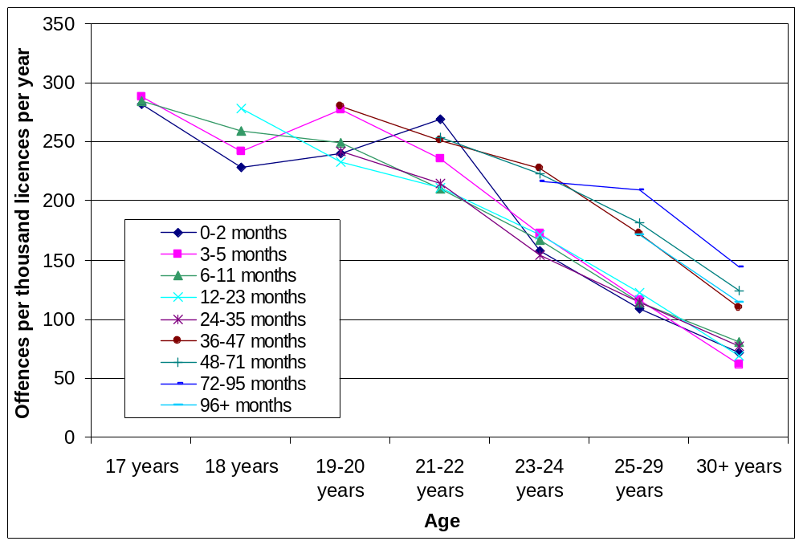
Figure 19 – Offence rate by age and driving experience
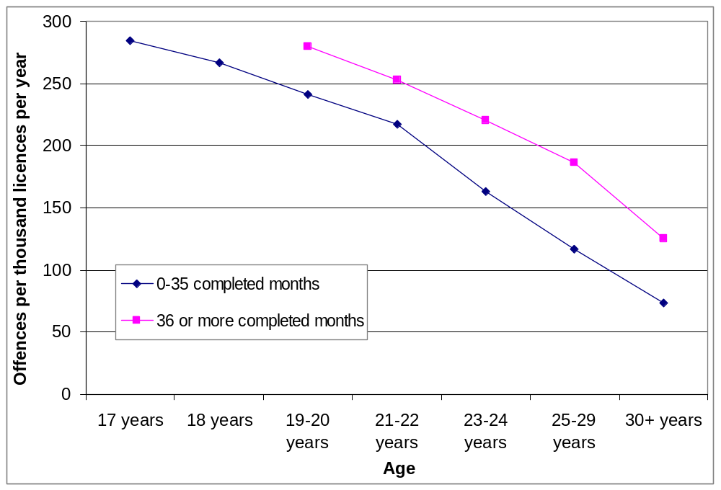
Figure 20 – Offence rate by age and driving experience (simplified)
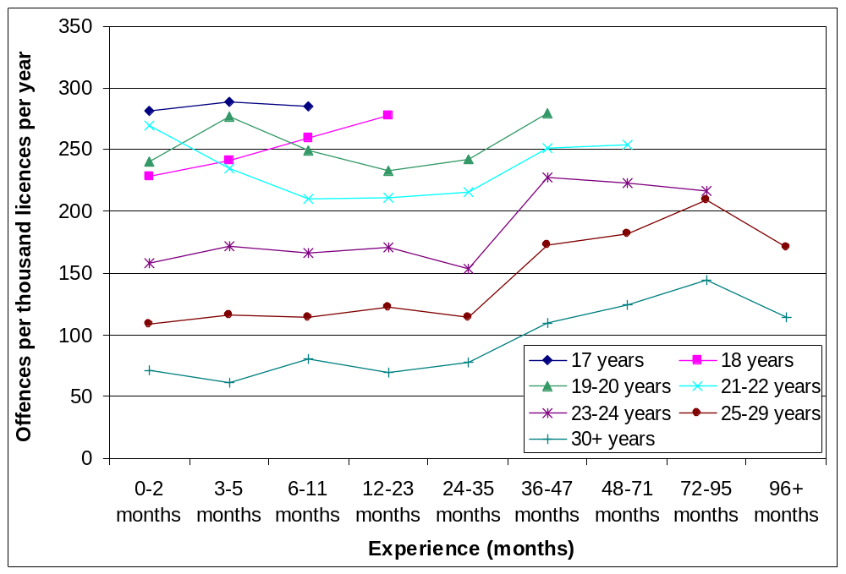
Figure 21 – Offence rate by driving experience and age

Licence type
Offence rate is shown as a function of licence type in Figure 22. Offence rates for provisional and full licence holders are very similar, while offence rates for holders of learner licences are far lower.
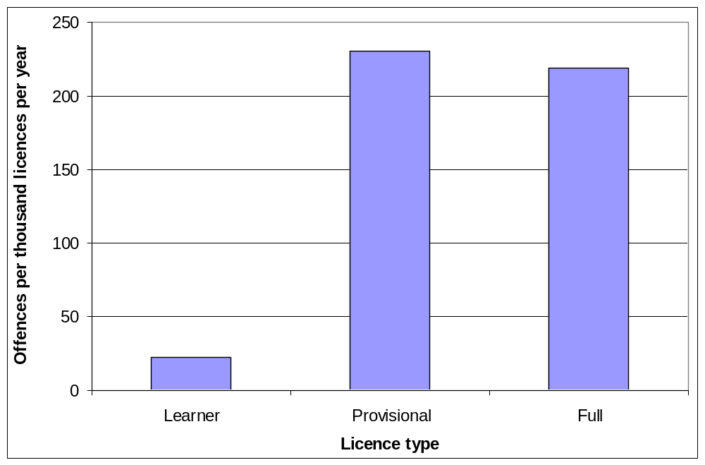
Figure 22 – Offence rate by licence type

Previous offences
In order to compare offence rates for drivers with and without prior offences, the time each driver was in the study was divided into two periods:
- The period from the date of obtaining a provisional licence up to and including the date of the first offence was defined as the ‘no prior offences’ period. For drivers with no recorded offences, this period comprised the whole of the time the driver spent in the study.
- The period from the day after the first offence until the end of the study (or the date when the licence became inactive, whichever was earlier) was defined as the ‘prior offences’ period. For drivers with no recorded offences, this period was zero days.
Figure 23 shows that for both males and females, the offence rate was far higher for drivers with prior offences than for drivers with no prior offences. Figure 24 shows that offence rates decline substantially with increasing age among drivers with and without prior offences. However, even the oldest drivers with prior offences have an offence rate similar to that of the very youngest drivers without prior offences. Likewise, Figure 25 shows that offence rates decline steeply with increasing experience among drivers with and without prior offences, but even the most experienced drivers with prior offences have offence rates similar to those of the least experienced drivers without prior offences.
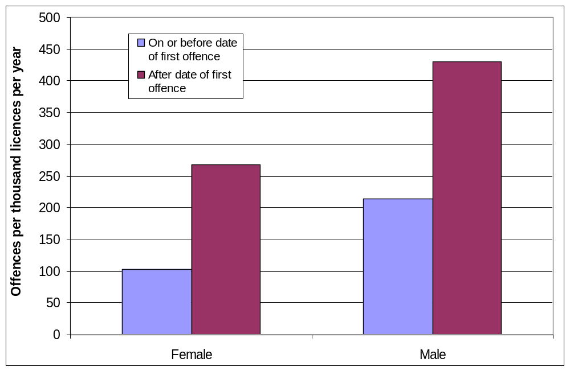
Figure 23 – Offence rate by offence history and gender
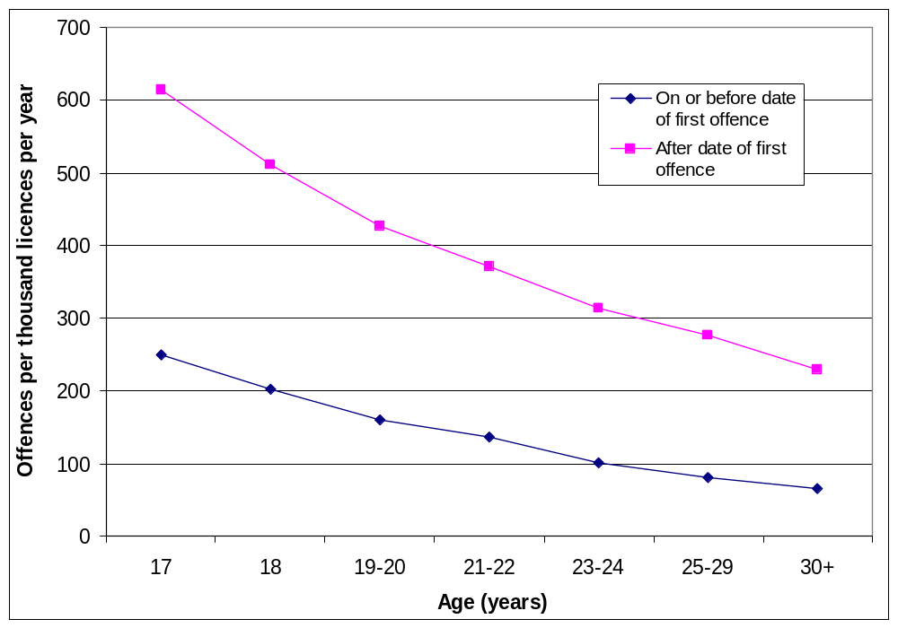
Figure 24 – Offence rate by age and offence history
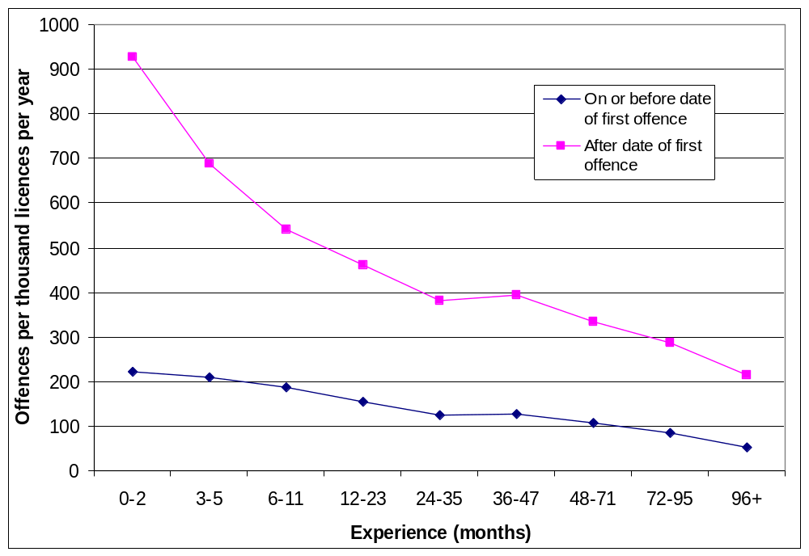
Figure 25 – Offence rate by experience and offence history

Other licence-related events
The data file received from Rego.ACT identified drivers who were currently banned from driving (due to their licence being cancelled, suspended or disqualified) and the date the ban commenced. Thus it was possible to calculate the number of days since the current ban (if any) commenced and to identify offences committed since the commencement of the ban. However, no information was obtained about the dates of any previous bans that had expired before the licence and offence data were extracted. The offence rate for drivers during their current driving ban was 152.5 offences per thousand licence holders per year, 32% lower than the overall average of 225.4 offences per thousand licence holders per year. The offence rate for males banned from driving was 32% lower than the overall average for all males and 51% lower than the rate for males with prior offences. The offence rate for banned females was 61% lower than the rate for all females and 79% lower than the rate for females with prior offences.
Road Ready Plus is an optional program for ACT drivers aged less than 26 years who have held a provisional licence for at least six months. The available information included the date (if any) on which the driver completed the Road Ready Plus program. The offence rate after completing Road Ready Plus was found to be 254.4 offences per thousand licence holders per year, 13% higher than the overall average of 225.4 offences per thousand licence holders per year.
Drivers who obtained a motorcycle licence before their car provisional licence were excluded from the study. However, there were some drivers in the study who obtained a motorcycle licence after their car provisional licence. The offence rate after obtaining a motorcycle licence (learner, provisional or full) was found to be 320.6 offences per thousand licence holders per year, 42% higher than the overall average of 225.4 offences per thousand licence holders per year.

Discussion

Limitations
Recorded traffic offences represent only a sub-set of all risk-taking by ACT drivers. The vast majority of risky driving behaviour goes unrecorded because it occurs when no enforcement activity is present. Nevertheless, official records of traffic offences form the largest and most representative body of information available regarding driver risk-taking. Traffic offence records were analysed to identify the demographic groups within the ACT driving population most likely to engage in risky driving behaviour.
Unfortunately, very little information concerning drink-driving offences could be included in the analyses. The project team did not learn until after the offence data had been supplied by Rego.ACT that in most cases drink-driving does not result in the recording of an offence but is recorded elsewhere in the ACT licensing system. Fortunately, despite the seriousness of the risk involved in each such offence, drink-driving offences comprise a small proportion of all traffic offences. In a study of traffic offences in New South Wales (NSW), Catchpole (2005) found that drink-driving offences comprised only 4.1% of risky offences committed by 17–23 year old drivers and 3.7% across all age groups. Thus the absence of drink driving offences from the data made available for the present study is unlikely to have had a significant impact on the pattern of results that emerged from the analyses.
The study was limited to offences committed up to 8 December 2004 by drivers whose first ACT learner and provisional car licences were issued from 1 January 1994 onwards. Thus all drivers in the study had less than 11 years experience. The great majority of drivers obtain a provisional licence within the first few years after reaching the legal minimum age (17 years). Thus the limitation on driving experience ensured that there would be very few drivers in the study aged beyond about 30 years. Given the steep decline in offence rates with increasing age established in Section 3.2.1, it is likely that the average offence rate across the full age spectrum of the ACT driving community is lower than the average offence rate (225.4 offences per thousand licence holders per year) found in the present study. However, this is not likely to have impacted on the ability of the study to identify the sub-population most likely to engage in risky driving behaviour.
The information obtained about each licence holder in the study included any current disqualification, cancellation or suspension of the licence and the date any such ban commenced. Thus for those licence holders who were banned from driving at the time of the data extraction, it was possible to identify offences that were committed during the current driving ban. However, no information was obtained concerning bans that may have been imposed earlier in the driver’s history but expired before the time of the data extraction. The calculated offence rates therefore apply to all holders of provisional and full car driver licences, whether active, suspended, cancelled or disqualified; only licences classified as ‘inactive’ by Rego.ACT were excluded from the main analyses. It was found in Section 3.2.5 that offence rates during the current ban (if any) were 32% lower than the overall average offence rate. It is likely that a similar drop in offence rate would have occurred during any previous driving bans, leading to a slight reduction in the overall average offence rate. Thus the average rate of offences among drivers whose licence is not currently cancelled, disqualified or suspended is likely to be slightly higher than the overall average offence rate of 225.4 offences per thousand licence holders per year found in the present study.

Influence of gender, age and experience on risky driving
Analysis of risky traffic offences committed by ACT drivers licensed between 1994 and 2004 clearly revealed the influence of gender on risky driving, with offence rates for male drivers being roughly double those for females. This is consistent with the results of previous studies of traffic offences (McColl, 2001; Catchpole, 2005). The much higher offence rate for males is only to a minor extent explained by greater exposure, since the Survey of Motor Vehicle Use indicates that average distance driven per annum is only five per cent higher for males than females in the 15–24 and 25–54 age groups (ABS, 2001). Thus it is clear that the rate of risky offending per distance driven is considerably higher for males than for females, especially among the youngest drivers. The offence rate per thousand licence holders per year is about 140% higher for males than females among 17 and 18 year old drivers, reducing to about 80% higher for males among drivers aged 23 years or more.
The offence rate was found to decrease with increasing age, with the decrease being more rapid for males than for females. In these respects, the present findings were similar to those found for offences in NSW by Catchpole (2005). However, some important differences were also observed. Whilst the offence rate in NSW was found to rise initially from age 17 to about age 19 before subsequently falling with further increases in age, there was no sign of any initial increase for ACT drivers. For males, the offence rate fell consistently from age 17 onwards; for females, the rate was initially fairly constant from age 17 to about age 21 or 22, before falling with further increases in age.
Amongst males, the offence rate was found to fall with increasing experience, apart from an isolated upward surge after completing three years of driving since obtaining a provisional licence. In view of the high correlation between age and experience, with the older drivers generally being the more experienced, it was of course expected that the relationship between offence rate and experience would be similar to that between offence rate and age. Thus it was not immediately clear from the bivariate analyses whether increasing age or increasing experience or a combination of the two should be seen as responsible for the decline in the offence rate. Amongst females, the offence rate was initially fairly constant for the first three years of driving experience, then rose in the fourth year before falling again from about 6–8 years experience. The similarity between the offence-rate-versus-age curve and the offence-rate-versus-experience curve was less for females than for males, perhaps indicating a lower correlation between age and experience due to a greater spread of licensing ages among females.
The generally decreasing trend for offence rates might be the result of age-related factors, such as a general tendency toward decreasing recklessness not only on the road but in all areas of life. Alternatively, it may be the result of experience-related factors, such as a progressive improvement in the driver’s ability to assess the risk inherent in driving situations. To help distinguish between these competing possibilities, further breakdowns were conducted by age and experience simultaneously. When the effect of experience was controlled by examining the relationship between offence rate and experience for drivers within narrow bands of driving experience, it was found that the offence rate falls steeply with increasing age for drivers within each experience group. Thus the generally decreasing trend for offence rates is not solely the result of experience-related factors; age or related factors must contribute to the decrease.
When the effect of age was controlled by examining the relationship between offence rate and experience for drivers within narrow age bands, the decreasing trend was no longer apparent. For most age bands, the offence rate was found to remain fairly constant during the first three years of driving, before rising sharply in the fourth year. Thus it is clear that increasing experience makes no contribution to the decrease in offence rate with increasing age. The decrease appears to be due solely to age and age-related factors.
The sharp increase in the rate of risky traffic offences in the fourth year of driving is of particular interest because it coincides with graduation from a provisional licence to a full licence and the removal of the restrictions that apply to provisional licence holders. Provisional licence holders are restricted to four demerit points before automatic loss of licence is imposed (or eight points for the small minority of drivers who have completed the Road Ready Plus program), but this limit is relaxed to twelve points for full licence holders. It is possible that the demerit point limit acts as a significant deterrent to offending. Indeed, Styles, Imberger and Catchpole (2004) found that young male ACT drivers often report that demerit points are an especially salient negative consequence of risky driving. The relaxation of the demerit point limit for full licence holders may therefore lead to increased offending in the fourth year of driving. The other major change at this time is the relaxation of the blood alcohol concentration (BAC) limit from 0.02 to 0.05 g/100 mL. Although alcohol offences were largely excluded from the data supplied for the study, it is possible that increased consumption of alcohol by new full licence holders leads to an increase in risk-taking of all kinds. Even without exceeding the legal limit, increased BAC levels may lead to increased tendency to speed, run red lights and take other risks on the road.

Drivers with prior offences
All other things being equal, is a driver who has committed a risky driving offence in the past more likely to commit future offences than a driver who has never committed such an offence? To answer this question, offence rates were calculated for drivers who had and drivers who had not committed previous offences. Among both males and females, offence rates were substantially higher for drivers with previous offences than for drivers without previous offences. This result is consistent with a study by Di Pietro et al. (2004), who also found that ACT drivers who have offended in the past are more likely to offend in the future than drivers who have never previously offended.
Elevated offence rates for drivers with previous offences were found not only for males and females but also for drivers at all ages and at all levels of experience. It is therefore clear that additional factors not highly correlated with gender, age or experience contribute to determining the probability that a driver will commit a risky traffic offence, and that at least some of these factors are fairly stable over time. Prior offences were found to be more important than gender in determining offence rates, with the offence rate for females who have committed a previous offence being higher than the rate for males who have no previous offences. Offence rates for the oldest and most experienced drivers who had committed prior offences were found to be approximately equal to offence rates for the youngest and least experienced drivers who had no prior offences.

Other influences on risky driving
Drivers who had completed the optional Road Ready Plus program for provisional licence holders were found to have an offence rate 13% higher than the overall rate for the entire driver sample. Based on the findings of an evaluation of Road Ready Plus by Di Pietro et al. (2004), it appears likely that this elevated offence rate is a result of the increased demerit point allowance associated with completion of Road Ready Plus rather than the content of the program. The increased demerit point allowance attracts to the program drivers who have offended in the past and are likely to offend again in the future.
The offence rate for drivers who had obtained a motorcycle licence (learner, provisional or full) after obtaining their car provisional licence was found to be 42% higher than the overall rate for the entire driver sample. This difference is partly attributable to the preponderance of males among motorcycle licence holders. Other factors must also be at work, however, since the offence rate for drivers who have obtained a motorcycle licence (320.6 offences per thousand drivers per year) is higher than the rate for all male drivers (309.8 offences per thousand drivers per year). It is not known whether drivers who hold both motorcycle and car licences may have greater exposure (distance driven or ridden per unit time), and hence greater opportunity to commit offences, than other drivers. Riding a motorcycle is in itself a comparatively risky activity, carrying a far greater probability of death or injury than driving a car for the same distance. It is possible that drivers who are willing to take the risk of riding a motorcycle are also more willing than other drivers to engage in other forms of risky driving behaviour.
In principle, the cancellation, disqualification or suspension of a driver’s licence should prevent all driving and therefore completely eliminate risky driving. However, some drivers continue to drive even while banned. For males and females combined, the offence rate during a driving ban was found to be 32% lower than the overall offence rate and 59% lower than the offence rate for drivers with prior offences. This reduction is presumably due in large part to reduced exposure during the ban, although it is not clear whether the reduction comprises a partial exposure reduction by all banned drivers or a complete cessation of driving by some coupled with little or no reduction by others. Some drivers who continue to drive during the period of the ban may reduce their risk-taking in an effort to avoid coming to attention again before the ban expires, which would also contribute to reduced offence rates among banned drivers. Among males, the offence rate for banned drivers was found to be 51% lower than the rate for those with prior offences; among females, the corresponding reduction was 79%. Thus it appears that driving bans (cancellation, suspension or disqualification) are more effective in either reducing exposure or reducing risk-taking among females than among males.
The offence rate for holders of learner licences was found to be only 10% of the rate for holders of solo (provisional and full) licences. It is likely that at least two factors contribute to the very low rates for learner licence holders: firstly, learners drive far less each week on average than provisional and full licence holders; and, secondly, the presence of the fully licensed supervisor, in many cases a parent, almost certainly inhibits risk-taking.

Conclusions

Extent of risky driving among young drivers in the ACT
The telephone survey revealed that almost all young drivers in the ACT engage in some form of risky driving on at least an occasional basis. Ninety per cent of survey respondents reported that they had exceeded the speed limit at some time in the last few weeks. There was considerable variation in the frequency of speeding, with many respondents reporting that they do so very rarely, but a quarter of all respondents indicating that they speed most times or every time they drive. There was also considerable variation in frequency between different risky driving behaviours, with over 40% of respondents admitting to driving aggressively and using a hand-held mobile phone while driving in the last few weeks but only 15% reporting that they had run a red light in the last few weeks.

Influences on risky driving
The study investigated the importance of a variety of factors in determining the frequency of risk-taking by young ACT drivers.
Gender: In the telephone survey, the self-reported frequency of speeding, using a hand-held mobile phone while driving and driving aggressively was slightly higher for males than for females, although only for aggressive driving did the gender difference emerge as significant in the logistic regressions. The influence of gender on risky traffic offences was much more clear-cut, with the rate per thousand drivers per year for males being roughly double that for females. Exposure differences explain the higher rate of risky offences for males only to a minor extent. It seems likely that gender differences in risk-taking are largely the result of physiological differences and/or the differing social norms and expectations applying to young males and females.
Age: There was no apparent effect of age on self-reported risk-taking for the four risky behaviours examined in the telephone survey; however, it should be noted that survey respondents were restricted to a narrow age range (17–21 years). Examination of the rate of risky traffic offences per thousand drivers per year revealed a clear decrease in risk-taking with increasing age, especially for males. The influence of age was even more apparent once the effect of experience was removed, with drivers in each experience group showing a steep decline in offence rates with increasing age.
Experience: Speeding, the most commonly reported of the four risky behaviours examined in the telephone survey, was found in the logistic regressions to be significantly influenced by driving experience, with respondents who had held a solo licence for longer being more likely to report speeding at least occasionally over the last few weeks. Experience also had a statistically significant effect on the frequency of aggressive driving: the more total hours of driving experience the driver had accumulated since acquiring a provisional licence, the more likely it was that the driver would report having driven aggressively in the last few weeks. Traffic offence rates decrease with increasing experience, but this was found to be an artefact of the high correlation between experience and the age of the driver. Once the influence of age was removed by examining drivers at different levels of experience within narrow age bands, it became clear that offence rates not only do not decrease with increasing experience but, on the contrary, increase markedly after three years of driving. It seems likely that this increase is related to the relaxation of BAC and demerit point restrictions when graduating from a provisional licence to a full licence. Increased consumption of alcohol may lead to increased risk-taking even among drivers who do not exceed the legal BAC limit. The higher demerit point limit applying to full licence holders removes an important inhibiting factor and may result in increased willingness to take risks.
Habit: Telephone survey respondents offered a variety of reasons for engaging in risky behaviours, most of which related to the utility of the behaviour, to over-confidence or to the actions of other road users. None of the responses implied that the formation of driving habits contributed to the performance of risky driving behaviours. Although respondents did not mention habits, their involvement cannot be ruled out on the basis of the present study. Habits are by definition subconscious and thus they are less likely than factors such as confidence to be described in response to open ended questions like those used in the present study. The role of habit in risky driving requires further investigation by other methods.
Over-confidence: The reasons offered by telephone survey respondents for engaging in each of four risky driving behaviours implied that over-confidence contributes to speeding, using a hand-held mobile phone while driving and running red lights, but not to aggressive driving. However, neither higher levels of confidence nor lower expectations of adverse consequences were found in the logistic regressions to be significantly associated with higher levels of risk-taking. On the contrary, not believing oneself to be safer than other drivers of the same age and gender was found to be associated with more frequent speeding and aggressive driving, suggesting an accurate rather than an over-confident self-assessment. The contribution of over-confidence to the increase in risk-taking with driving experience requires further investigation.
Risky driving by parents: The telephone survey clearly revealed the influence of parental driving style on risk-taking by respondents. Respondents explicitly acknowledged the influence of their fathers’ and their mothers’ driving on their own driving style. In addition, there were statistically significant associations between the self-reported frequency of risky driving behaviours by the respondent and the frequency of their parents engaging in the same behaviours. All associations were positive, with a higher frequency of risky behaviour by the parent being associated with a higher frequency of the same risky behaviour by the young driver. However, despite the significant links between the behaviour of respondents and their parents, most self-reported speeders have parents who were not reported to be speeders.

Target groups for countermeasure development
The study has clearly identified several potential target groups for the development of measures to reduce risky driving behaviour. Different countermeasures are required for the different target groups.
The primary focus of efforts to reduce risky driving offences should be on drivers who have already committed at least one risky driving offence, since they are more likely than other drivers to offend in the future. The impact of prior offences on future offence rates is greater than the effect of either gender or age, so focussing on drivers with prior offences is the most efficient way of identifying potential future offenders. It is also likely to be more acceptable to the community to focus on drivers who have already committed offences than to focus on demographic groups whose members are considered likely to commit future offences.
After prior offences, the next most important influence on the frequency of risky driving behaviour is gender, with young males admitting to more frequent risky behaviour and having roughly twice as many risky offences per driver as young females. It may not be acceptable to the community to apply mandatory programs selectively to males only. Nevertheless, it is important that optional programs, such as the ACT’s existing Road Ready Plus program, be marketed in ways that appeal particularly to males. Furthermore, the content of all programs intended to reduce risk-taking, whether mandatory or optional, should be designed to cater especially for the needs of male participants.
High levels of risky driving are associated specifically with youthfulness rather than with lack of driving experience. Older novice drivers have a much lower rate of risky driving offences than do younger novice drivers. Programs intended to reduce the frequency of risky driving should focus on the youngest drivers rather than the least experienced drivers.
Offence rates indicate that, particularly among males but also to some extent among females, significant levels of risk-taking continue even when the driver’s licence is suspended, cancelled or disqualified. Indeed, the rate of risky offences is higher among males currently banned from driving than among females overall (the vast majority of whom are not banned) and approximately equal to the rate among males with no prior offences. Thus there is a clear need to address risky driving by people, especially males, who are currently banned from driving. This might be achieved by an enforcement campaign targeting those who continue while banned, supported by appropriate publicity.
The substantial increase in the rate of risky offences in the fourth year of driving implies a need for a program aimed at drivers graduating from a provisional licence to a full licence. It may be possible to reduce risk-taking among new full licence holders by educating them about the effect of alcohol on driving behaviour at legal BACs as well as illegal BACs. To reduce the impact of the sudden increase in the demerit point limit from four to twelve points when graduating from a provisional to a full licence, it would be worth considering a graduated increase. For example, the demerit point limit could be set at six points in the first year on a full licence, increasing by two points per year and reaching twelve points in the fourth year of driving on a full licence. This would require an adjustment to the demerit point incentive offered to drivers to complete the Road Ready Plus program. Perhaps the most appropriate adjustment would be an immediate increase from four to six points on completion of Road Ready Plus, followed by a further two point increase each year thereafter until a maximum of twelve points is reached. In other words, drivers could commence the graduated increase from four to twelve points immediately on completion of Road Ready Plus, without having to wait until they hold a full licence.
The links established by the present study between the risk-taking of novice drivers and their parents suggest that risk-taking by novices could be reduced by programs that address risky driving by the parents of pre-driving-age children. The present study did not investigate the age at which children are most susceptible to the influence of their parents’ driving behaviour, but it seems reasonable to suppose that behaviour in the years immediately before the child begins learning to drive will be the most closely observed and best understood by the child and will therefore have the greatest influence on the child’s normative beliefs. This suggests that a program aimed at parents should probably focus on the parents of pre-driving secondary school students.

References
ABS (2001). Survey of Motor Vehicle Use, 31 October 2000. (Australian Bureau of Statistics: Canberra, ACT).
Catchpole J (1998). Age, driving experience and type of accident involvement. In: Road Safety Conference 1998: Proceedings, volume 1, pp 196–201. (Land Transport Safety Authority: Wellington, NZ).
Catchpole J (2005). Learning to take risks: The influence of age and experience on risky driving. Research Report ARR 362. (ARRB Group Ltd: Vermont South, Victoria).
Catchpole J, Cairney P and Macdonald W (1994). Why Are Young Drivers Over-Represented in Traffic Accidents? Special Report No. SR 50. (Australian Road Research Board: Vermont South, Vic).
Catchpole JE, Macdonald WA and Bowland L (1994). Young driver research program: The influence of age-related and experience-related factors on reported driving behaviour and crashes. Consultant Report No. CR 143. (Federal Office of Road Safety: Canberra, ACT)
Di Pietro G, Hughes I and Catchpole J (2004). Evaluation of the Inexperienced Solo Driver Program Road Ready Plus. (GDP Consultancy: Wheelers Hill, Victoria).
Evans L and Wasielewski P (1983). Risky driving related to driver and vehicle characteristics. Accident Analysis and Prevention, 15 (2), 121 -136.
Ferguson SA (2003). Other high-risk factors for young drivers – how graduated licensing does, doesn’t or could address them. Journal of Safety Research, 34, 71–77.
Fildes BN, Rumbold G and Leening A (1991). Speed behaviour and drivers' attitudes to speeding. Report No. 16. (Monash University Accident Research Centre: Clayton, Victoria).
Goldstein LG (1972). Youthful drivers as a special safety problem. Accident Analysis and Prevention, 4 (3), 153–189.
Harrington DM (1972). The young driver follow-up study: an evaluation of the role of human factors in the first four years of driving. Accident Analysis and Prevention, 4 (3), 191–240.
Jonah BA (1986). Accident risk and risk-taking behaviour among young drivers. Accident Analysis and Prevention, 18 (4), 255–271.
Jonah BA and Dawson NE (1987). Youth and risk: Age differences in risky driving, risk perception and risk utility. Alcohol, Drugs and Driving, 3 (3–4), 13–29.
Lewis C (1985). Adolescents' traffic casualties: Causes and interventions. In: L Evans and RC Schwing (Eds) Human Behavior and Traffic Safety. New York: Plenum.
Macdonald WA (1994). Young Driver Research Program - A review of information on young driver crashes. Report No. CR 128. (Federal Office of Road Safety: Canberra, ACT).
McColl R (2001). Age and sex profiles of speeding and drink driving offenders and drivers involved in casualty crashes. Report No. 1/2001. (Transport SA: Walkerville, South Australia).
Senserrick T and Whelan M (2003). Graduated driver licensing: Effectiveness of systems and individual components. Report No. 209. (Monash University Accident Research Centre: Clayton, Victoria).
Styles T, Imberger K and Catchpole J (2005). Understanding risk-taking by young male drivers. Research Report ARR 363. (ARRB Group Ltd: Vermont South, Victoria).

Appendix A—Survey questionnaire

1. Hello, my name is ........... from Nexus Research. Today we are surveying young respondents in the ACT about their driving style. Is there anyone in the household aged 17 to 21 years that I could ask a few questions? [Reintroduce if necessary]

(50)
❑ 1 Yes
❑ 2 No

[IF THE ANSWER IS 1, THEN SKIP TO QUESTION 4]

2. Do you have a male family member or friend aged 17 to 21 years who might be willing to answer some questions about driving. [If no, keep hitting the escape key to return to call screen and click on code '8' - Screened Out]

(51)
❑ 1 Yes

3. Could I please have the name and contact phone number for that person(s)

[Record contact details on the sheet of paper provided] [Thank respondent and terminate. Keep hitting the escape key to return to call screen & click on code '8' - Screened Out]

(52)
❑ 1 Escape back [Don't click on Code 1]

4. This research will help safety experts understand why different respondents have different driving styles. Would it be alright if I asked you a few questions about your driving?

(53)
❑ 1 Yes - Continue
❑ 2 No

[IF THE ANSWER IS 2, THEN SKIP TO QUESTION 2]

5. Do you have a provisional or full driver's licence?

(54)
❑ 1 Yes
❑ 2 No

[IF THE ANSWER IS 2, THEN SKIP TO QUESTION 2]

6. Do you drive a car, utility or van at least twice a week on average?

(55)
❑ 1 Yes
❑ 2 No

[IF THE ANSWER IS 2, THEN SKIP TO QUESTION 2]

7. Can I ask what your age is please?

(56-57)
❑ 17 years
❑ 18 years
❑ 19 years
❑ 20 years
❑ 21 years

8. Record gender of respondent

(58)
❑ 1 Male
❑ 2 Female

9. Thinking about the car you drive most often, who does the car belong to? [Do not read out]

(59-60)
❑ 01 You
❑ 02 Your parent(s)
❑ 03 Other family member(s)
❑ 04 Your employer
❑ 05 A friend
❑ 98 Other

[IF THE ANSWER IS NOT 98, THEN SKIP TO QUESTION 11]

10. Please specify 'Other' in previous question

____________________________________________________________ (61-110)

11. How old is that car? [2 digit code. Less than 1 year = 00. DK=99]

Age of Car (Years) .. ____ (111-112)

12. In what year did you first get a provisional driver's licence? [DK=9999]

Year .. ________ (113-116)

[IF THE ANSWER IS 9999, THEN SKIP TO QUESTION 14]

13. What month was it?

(117-118)
❑ 01 January
❑ 02 February
❑ 03 March
❑ 04 April
❑ 05 May
❑ 06 June
❑ 07 July
❑ 08 August
❑ 09 September
❑ 10 October
❑ 11 November
❑ 12 December
❑ 99 Don't know/Can't remember

14. Approximately how many hours do you spend driving in an average week? [Remember they drive at least twice a week on average. Type in number and hit <Next>. DK=999]

Hours Driving .. ______ (119-121)

15. And approximately how many kilometres do you drive in an average week? [Type in number and hit <Next>. DK=9999]

No of kilometres .. ________ (122-125)

16. Compared with other [Answer to Q.8] drivers your age, do you consider your driving to be ..........? [Read out]

(126)
❑ 1 Much more skilful
❑ 2 A little more skilful
❑ 3 About the same
❑ 4 A little less skilful
❑ 5 Much less skilful
❑ 6 [DNRO] Don't Know

17. Compared with other [Answer to Q.8] drivers your age, do you consider your driving to be ..........? [Read out]

(127)
❑ 1 Much safer
❑ 2 A little safer
❑ 3 About the same
❑ 4 A little less safe
❑ 5 Much less safe
❑ 6 [DNRO] Don't Know

18. The next questions are about driving actions that some respondents consider to be dangerous. The information you provide will not be used against you in any way. Our code of ethics doesn't allow Nexus Research to pass on any information that can identify you to any person or organisation, so please feel free to be completely honest with your answers.

(128)
❑ 1 Continue

19. In the last few weeks, how often have you driven faster than the speed limit for the road you were on? [Read out]

(129)
❑ 1 Never
❑ 2 Very rarely
❑ 3 Occasionally
❑ 4 Most times you drive
❑ 5 Every time you drive
❑ 6 [DNRO] Don't know

20. Thinking back to your driving in the first few weeks after you got your provisional licence, how often did you drive faster than the speed limit? [Read out]

(130)
❑ 1 Never
❑ 2 Very rarely
❑ 3 Occasionally
❑ 4 Most times you drove
❑ 5 Every time you drove
❑ 6 [DNRO] Don't know

[IF THE ANSWER TO QUESTION 19 IS 1, THEN SKIP TO QUESTION 22]

21. What are the reasons why you sometimes drive faster than the speed limit? Any others? [DK=99]

__________________________________________________________ (131-330)

__________________________________________________________

__________________________________________________________

__________________________________________________________

22. What effect do you think driving faster than the speed limit has on your chance of being involved in an accident? Would you say that it ........? [Read out]

(331)
❑ 1 Greatly increases your chance of being in an accident
❑ 2 Slightly increases your chance
❑ 3 Makes no difference
❑ 4 Slightly reduces your chance
❑ 5 Greatly reduces your chance of being in an accident
❑ 6 [DNRO] Don't know

[IF THE ANSWER TO QUESTION 19 IS 1, THEN SKIP TO QUESTION 24]

23. Have you ever been involved in a road accident after you drove faster than the speed limit?

(332)
❑ 1 Yes
❑ 2 No
❑ 3 Don't know
❑ 4 Refused

24. How likely is it that you will be fined by the police if you drive faster than the speed limit for the road you are on? [Read out]

(333)
❑ 1 Very unlikely
❑ 2 Unlikely
❑ 3 Moderate chance
❑ 4 Likely
❑ 5 Very likely
❑ 6 [DNRO] Don't know

[IF THE ANSWER TO QUESTION 19 IS 1, THEN SKIP TO QUESTION 26]

25. Have you ever been fined by the police after you drove faster than the speed limit?

(334)
❑ 1 Yes
❑ 2 No
❑ 3 Don't Know
❑ 4 Refused

26. In the last few weeks, how often have you used a handheld mobile phone while you were driving a moving vehicle? [Read out]

(335)
❑ 1 Never
❑ 2 Very rarely
❑ 3 Occasionally
❑ 4 Most times you drive
❑ 5 Every time you drive
❑ 6 [DNRO] Don't know

27. Thinking back to your driving in the first few weeks after you got your provisional licence, how often did you use a handheld mobile phone while you were driving? [Read out]

(336)
❑ 1 Never
❑ 2 Very rarely
❑ 3 Occasionally
❑ 4 Most times you drove
❑ 5 Every time you drove
❑ 6 [DNRO] Don't know

[IF THE ANSWER TO QUESTION 26 IS 1, THEN SKIP TO QUESTION 29]

28. What are the reasons why you sometimes use a handheld mobile phone while you are driving? Any others? [DK=99]

__________________________________________________________ (337-536)

__________________________________________________________

__________________________________________________________

__________________________________________________________

29. What effect do you think using a handheld mobile phone while you are driving has on your chance of being involved in an accident? Would you say that it ........? [Read out]

(537)
❑ 1 Greatly increases your chance of being in an accident
❑ 2 Slightly increases your chance
❑ 3 Makes no difference
❑ 4 Slightly reduces your chance
❑ 5 Greatly reduces your chance of being in an accident
❑ 6 [DNRO] Don't Know

[IF THE ANSWER TO QUESTION 26 IS 1, THEN SKIP TO QUESTION 31]

30. Have you ever been involved in a road accident after you used a handheld mobile phone while you were driving?

(538)
❑ 1 Yes
❑ 2 No
❑ 3 Don't Know
❑ 4 Refused

31. How likely is it that you will be fined by the police if you use a handheld mobile phone while you are driving? [Read out]

(539)
❑ 1 Very unlikely
❑ 2 Unlikely
❑ 3 Moderate chance
❑ 4 Likely
❑ 5 Very likely
❑ 6 [DNRO] Don't know

[IF THE ANSWER TO QUESTION 26 IS 1, THEN SKIP TO QUESTION 33]

32. Have you ever been fined by the police after you used a handheld mobile phone while you were driving?

(540)
❑ 1 Yes
❑ 2 No
❑ 3 Don't Know
❑ 4 Refused

33. In the last few weeks, how often have you driven through a red traffic light? [Read out]

(541)
❑ 1 Never
❑ 2 Very rarely
❑ 3 Occasionally
❑ 4 Most times you drive
❑ 5 Every time you drive
❑ 6 [DNRO] Don't know

34. Thinking back to your driving in the first few weeks after you got your provisional licence, how often did you drive through a red traffic light? [Read out]

(542)
❑ 1 Never
❑ 2 Very rarely
❑ 3 Occasionally
❑ 4 Most times you drove
❑ 5 Every time you drove
❑ 6 [DNRO] Don't know

[IF THE ANSWER TO QUESTION 33 IS 1, THEN SKIP TO QUESTION 36]

35. What are the reasons why you sometimes drive through a red traffic light? Any others? [DK=99]

__________________________________________________________ (543-742)

__________________________________________________________

__________________________________________________________

__________________________________________________________

36. What effect do you think driving through a red traffic light has on your chance of being involved in an accident? Would you say that it ........? [Read out]

(743)
❑ 1 Greatly increases your chance of being in an accident
❑ 2 Slightly increases your chance
❑ 3 Makes no difference
❑ 4 Slightly reduces your chance
❑ 5 Greatly reduces your chance of being in an accident
❑ 6 [DNRO] Don't Know

[IF THE ANSWER TO QUESTION 33 IS 1, THEN SKIP TO QUESTION 38]

37. Have you ever been involved in a road accident after you drove through a red traffic light?

(744)
❑ 1 Yes
❑ 2 No
❑ 3 Don't Know
❑ 4 Refused

38. How likely is it that you will be fined by the police if you drive through a red traffic light? [Read out]

(745)
❑ 1 Very unlikely
❑ 2 Unlikely
❑ 3 Moderate chance
❑ 4 Likely
❑ 5 Very likely
❑ 6 [DNRO] Don't know

[IF THE ANSWER TO QUESTION 33 IS 1, THEN SKIP TO QUESTION 40]

39. Have you ever been fined by the police after you drove through a red traffic light?

(746)
❑ 1 Yes
❑ 2 No
❑ 3 Don't Know
❑ 4 Refused

40. In the last few weeks, how often have you driven in a way that is aggressive towards other drivers, such as tailgating or cutting other drivers off? Would you say that this happens ..........? [Read out]

(747)
❑ 1 Never
❑ 2 Very rarely
❑ 3 Occasionally
❑ 4 Most times you drive
❑ 5 Every time you drive
❑ 6 [DNRO] Don't know

41. Thinking back to your driving in the first few weeks after you got your provisional licence, how often did you drive aggressively towards other drivers? [Read out]

(748)
❑ 1 Never
❑ 2 Very rarely
❑ 3 Occasionally
❑ 4 Most times you drove
❑ 5 Every time you drove
❑ 6 [DNRO] Don't know

[IF THE ANSWER TO QUESTION 40 IS 1, THEN SKIP TO QUESTION 43]

42. What are the reasons why you sometimes drive aggressively towards other drivers? Any others? [DK=99]

__________________________________________________________ (749-948)

__________________________________________________________

__________________________________________________________

__________________________________________________________

43. Now a few questions about your father's and mother's driving. Please remember that Nexus Research can't pass on any information that can identify you or your parents.

(949)
❑ 1 Continue

44. In the years before you started learning to drive, how often did you ride in a car that was driven by your father? [Read out]

(950)
❑ 1 Never
❑ 2 Less than once a month
❑ 3 At least once a month
❑ 4 At least once a week
❑ 5 More often
❑ 6 [DNRO] Don't know/Can't remember

[IF THE ANSWER IS 1-2, THEN SKIP TO QUESTION 50]

45. When you rode in a car driven by your father, how often did he drive faster than the speed limit? [Read out]

(951)
❑ 1 Never
❑ 2 Very rarely
❑ 3 Occasionally
❑ 4 Most times he drove
❑ 5 Every time he drove
❑ 6 [DNRO] Don't know

46. How often did he use a handheld mobile phone while he was driving a moving vehicle? [Read out]

(952)
❑ 1 Never
❑ 2 Very rarely
❑ 3 Occasionally
❑ 4 Most times he drove
❑ 5 Every time he drove
❑ 6 [DNRO] Don't know

47. How often did he drive through a red traffic light? [Read out]

(953)
❑ 1 Never
❑ 2 Very rarely
❑ 3 Occasionally
❑ 4 Most times he drove
❑ 5 Every time he drove
❑ 6 [DNRO] Don't know

48. How often did he drive in a way that was aggressive towards other drivers, such as tailgating or cutting other drivers off ? [Read out]

(954)
❑ 1 Never
❑ 2 Very rarely
❑ 3 Occasionally
❑ 4 Most times he drove
❑ 5 Every time he drove
❑ 6 [DNRO] Don't know

49. How much influence would you say your father's driving style has had on the way you drive? [Read out]

(955)
❑ 1 No influence at all
❑ 2 Very little influence
❑ 3 Moderate influence
❑ 4 Strong influence
❑ 5 Very strong influence
❑ 6 [DNRO] Don't know

50. In the years before you started learning to drive, how often did you ride in a car that was driven by your mother? [Read out]

(956)
❑ 1 Never
❑ 2 Less than once a month
❑ 3 At least once a month
❑ 4 At least once a week
❑ 5 More often
❑ 6 [DNRO] Don't know/Can't remember

[IF THE ANSWER IS 1-2, THEN SKIP TO QUESTION 56]

51. When you rode in a car driven by your mother, how often did she drive faster than the speed limit? [Read out]

(957)
❑ 1 Never
❑ 2 Very rarely
❑ 3 Occasionally
❑ 4 Most times she drove
❑ 5 Every time she drove
❑ 6 [DNRO] Don't know

52. How often did she use a handheld mobile phone while she was driving a moving vehicle? [Read out]

(958)
❑ 1 Never
❑ 2 Very rarely
❑ 3 Occasionally
❑ 4 Most times she drove
❑ 5 Every time she drove
❑ 6 [DNRO] Don't know

53. How often did she drive through a red traffic light? [Read out]

(959)
❑ 1 Never
❑ 2 Very rarely
❑ 3 Occasionally
❑ 4 Most times she drove
❑ 5 Every time she drove
❑ 6 [DNRO] Don't know

54. How often did she drive in a way that was aggressive towards other drivers, such as tailgating or cutting other drivers off ? [Read out]

(960)
❑ 1 Never
❑ 2 Very rarely
❑ 3 Occasionally
❑ 4 Most times she drove
❑ 5 Every time she drove
❑ 6 [DNRO] Don't know

55. How much influence would you say your mother's driving style has had on the way you drive? [Read out]

(961)
❑ 1 No influence at all
❑ 2 Very little influence
❑ 3 Moderate influence
❑ 4 Strong influence
❑ 5 Very strong influence
❑ 6 [DNRO] Don't know

56. Finally, a few questions about your background. Which of the following best describes your occupation? [Read out. Can be multiple response. Hit <Next> to continue]

(962-967)
❑ 01 School student
❑ 02 University/TAFE/Other student
❑ 03 Employed up to 30 hours per week
❑ 04 Employed more than 30 hours per week
❑ 05 Unemployed
❑ 06 Home duties
❑ 98 Other
❑ 99 [DNRO] Refused

[IF THE ANSWER IS NOT 98, THEN SKIP TO QUESTION 58]

57. Please specify 'Other' in previous question

_________________________________________________________ (968-1017)

58. Are you presently living with .........? [Read out. Single response]

(1018)
❑ 1 One or both parents (or step-parents or adoptive parents)
❑ 2 Other family members (brother, sister, husband, wife etc)
❑ 3 Respondents who are not related to you
❑ 4 Living alone
❑ 5 [DNRO] Refused

59. What is the highest level of education you have completed? [Read out. Single response]

(1019-1020)
❑ 01 Primary
❑ 02 Secondary
❑ 03 University or TAFE
❑ 04 Trade qualification
❑ 98 Other

[IF THE ANSWER IS NOT 98, THEN SKIP TO QUESTION 61]

60. Please specify 'Other' in previous question

________________________________________________________ (1021-1070)

61. [If interview resulted from a contact, type in the person's name and hit <Next> to continue]

[That's all the questions I have for you ....... and just in case my supervisor wants to check my work, could I ask for your first name please. [Type in]

________________________________________________________ (1071-1086)

62. If interview resulted from a contact, type in the respondent's phone number

________________________________________________________ (1087-1106)

63. Thank you very much for your help. The information you have provided will help safety experts understand more about young drivers. Please be assured that your personal details will not be passed on by Nexus Research to any person or organisation. Just to remind you, my name is .......... from Nexus Research in Melbourne. If you have any queries please phone my supervisor on (03) 9428-1356.

[Please record your own interviewer's ID number to certify that this is a true, accurate and complete interview, conducted in accordance with IQCA standards and the MRSA Code of Professional Behaviour (ICC/ESOMAR), and that you will not disclose to any third party the content of this questionnaire or any other information relating to this project]

ID No. .. ________ (1107-1110)

Appendix B—Preparation of licence and offence data for analysis

Licence holders
The investigators requested that Rego.ACT supply selected data fields for ‘for all drivers who were issued with their first ACT driver licence (learner, provisional or full) from 1/1/1994 to the present’. The data extraction was run on 8/12/2004 and included licences issued up to and including that date. The file received from Rego.ACT contained 150 990 records, a surprisingly high number in relation to the total ACT population (all ages), which ranged from 300 000–320 000 during the study period.
Although it was expected that the data supplied would be confined to drivers who obtained their first ACT licence during the study period, it was found that 57% of records supplied had no learner licence issue date and 67% had no provisional licence issue date. The median age at issue of a full licence was 20 years for drivers with a recorded issue date for a learner or provisional licence, compared with 32 years for drivers with no issue date for a learner or provisional licence. Based on these observations, it appeared likely that many of the drivers who had an issue date for a full licence but no issue date for a learner or provisional licence had previously held a full licence, either in the ACT or in another jurisdiction. Records that were missing the issue date for either the learner licence or the provisional licence were excluded from the study in order to provide a representative sample of drivers whose driving experience since obtaining their first solo (provisional licence) was known.
Drivers were also excluded if:
- the recorded issue date for the provisional licence was before the driver was 17 years old
- the learner licence was issued before the driver was 15 years old
- the full licence was issued before the driver was 20 years old or before the driver had held a provisional licence for three years
- any licensing event was recorded as having occurred later than the data extraction (8/12/2004)
- any licensing events were recorded as having occurred out of order (e.g. provisional licence issued before learner licence)
- a motorcycle licence was issued prior to the issue of the provisional car licence.
In addition, the file was found to contain duplicate records for some licence numbers. The duplicate records were identical to the originals in all respects. The duplicates were excluded from the analyses.
After all exclusions, 43 542 drivers were eligible for inclusion in the analyses.

Offences
The offence data file received from Rego.ACT contained 323 006 records, including a small proportion of duplicates (repeated combinations of licence number, offence date, offence time and offence code). After excluding duplicates, 320 791 records remained.
A table supplied by Rego.ACT provided brief descriptions corresponding to each offence code. Using these descriptions, all offences were classified according to:
- the type of road user to whom the offence was relevant (pedestrian, passenger, learner licence holder, other driver or rider)
- the type of vehicle to which the offence was relevant (bicycle, motorcycle, heavy vehicle or generally applicable)
- the type of behaviour involved in the offence (speeding, parking, failing to display P plates, drink driving, etc)
- whether the offence increased the risk of an accident or injury.
After excluding non-risky offences and offences relating exclusively to passengers, pedestrians, pedal cyclists, motorcyclists and drivers of heavy vehicles, 105 800 offences remained. After further excluding offences committed by excluded drivers (see previous section for details), 44 707 offences remained. Offences committed before the driver was issued with a learner licence and offences committed after the licence became inactive were also excluded, finally leaving 44 451 offences for inclusion in the analyses. Of the remaining offences, 1434 were committed by holders of learner licences; these offences were excluded from most analyses.

Re-analysis of data from Catchpole (2004) shows that the ratio of the offence rate for drivers with 2 years experience to the rate for drivers with 0 years experience varies between 1.55 to 4.59 for drivers in various age groups. The ratio is higher for drivers aged 18-23 years than for older drivers.
A minority of the more experienced drivers will have experienced an accident or other adverse consequences and will presumably have arrived at a different conclusion.
Some respondents reported having received a provisional licence more than five years before the survey, which was impossible in view of the ACT minimum licensing age. Reported licence issue dates prior to the respondent’s 17th birthday were adjusted to the year and month of the respondent’s 17th birthday, as described in Section 2.2.1, before calculating the number of months of driving experience.

