Minutes of the
ACRS NSW Chapter
Annual General Meeting
24 June 2025

Held at: Transport for NSW, Elizabeth St Sydney
Attendance List: Held by ACRS National Office
Commenced: 5pm

Introduction, Acknowledgement of Country, Quorum

Dedication
The NSW Chapter AGM is dedicated to the memory of Dr Prasannah Prabhakharan (1986-2025).
- ACRS Member
- NSW Chapter Committee Member
- Immediate Past NSW Chapter Chair
- 2024 ACRS Young Leaders Oration Award

Minutes of the 2024 AGM
Minutes of the previous AGM were circulated via the registration process.
Motion: Move that the Minutes of the 2024 Meeting be Accepted.
Moved: Greg Casey Seconded: David Walekin
Carried

Chapter Chair’s Report – Delivered by M.Timms

NSW Chapter Committee Members

Name | Position
Prasannah Prabhakharan | Committee Member, Immediate Past Chair
Mick Timms | Chair
Tasha Prabhakar | Deputy Chair
David Beck | Secretary
John Crozier | Committee Member, ACRS Fellow
Tasha Prabhakar | Committee Member
Cass Gauld | Committee Member
Ralston Fernandes | Committee Member
David McTiernan | Committee Member
David Wakelin | Committee Member
Josh Devitt | Committee Member

E-Mobility Forum – 6 August 2024
Hybrid event held at Event Cinemas, George St Sydney, supported by the NRMA heard from five presenters.
- Local Government Perspective: Mr Phillip Devon, Manager Transport Network, Northern Beaches Council
- State Government Perspective: Mr Bernard Carlon, Director Road Safety & Maritime Safety, Centre for Road Safety
- Road Operator Perspective: Mr David Beck, Road Safety Technical Manager, Transurban
- Medical Perspective: Dr John Crozier, Visiting Medical Officer, Liverpool Hospital
- Researcher Perspective: Prof Narelle Haworth, Director CARRS-Q (Presenting Online)

ACRS Regional Road Safety Forums
- With the help of a TfNSW Community Road Safety Grant, NSW Chapter held regional forums in Orange (26 Feb) and Wagga Wagga (27 Feb)
- These forums provide a networking opportunity for regionally based stakeholders, professionals, and people with an interest in road safety.

PhD Invitational honouring Dr Prasannah Prabhakharan
An evening to honour Prasannah, the PhD Invitational heard from four candidates who were each allocate ten minutes to talk about their road safety research. Those candidates, pictured left to right, were:
- Greg Casey, University of Western Sydney, Heavy Vehicles and fatigue
- Caitlin Reeves, University of Newcastle, Automated Vehicles and trust
- Lyndall Cook, University of NSW, Child Restraint Safety
- Anvay Parab, University of NSW, Motorcycle safety and pelvic injuries from fuel tank impacts
Held with the support of UNSW

NSW regionally-based, early career, ARSC Registration
A response on behalf of the Prabhakaran family was delivered by Prasannah’s brother, Prakash. He described how much ACRS meant to his late brother by announcing Prasannah left the organisation a $5,000 bequest.
The bequest will fund the ARSC registration fee of a regionally based NSW road safety practitioner. The funding is expected to commence in time for the ARSC 2026 and run for four years.
The NSW Chapter committee will run a process to select recipients.

Parliamentary Inquiries and Related Submissions
Committee | Inquiry
Joint Parliamentary Standing Committee on Road Safety (Staysafe) | Religious Exemptions for the wearing of helmets*
Legislative Council Transport and the Arts Committee | E-scooters, E-bikes and related mobility*
Legislative Assembly Committee on Transport and Infrastructure | Infrastructure for electric and alternative energy source vehicles in NSW (hearings yet to be held)
Legislative Council Customer Service Committee | Public Toilets
Transport for NSW | Roads Act Review

Media and Community Engagement
- ACRS media releases
- TV News Interviews
  - WIN TV News - Illawarra, Riverina
  - 7 News - Central West, Riverina
- Radio Interviews and News Grabs
  - ABC Illawarra, Riverina, Brisbane
  - Commercial & Community (Wagga, Orange)
- Road Safety Advisory Council participant
- Launch of 2025 National Road Safety Week
- Meetings with Roads Minister Graham, Opposition Road Minister Ward, MP’s Kylie Wilkinson, Phil Donato, Joe McGirr, Michael McCormack (Federal)

Treasury Report
Bank Account Balance 1 May 2024 $16,631.77
Bank Account Balance 1 May 2025 $14,982.49

Income | Amount
ACRS chapter contribution | $1,000
NRMA E-Mobility Forum Sponsorship | $800
Bank Interest | $1.21
Total | $1,801.21
Grants | Amount
TfNSW Community Road Safety Grants | Up to $5000

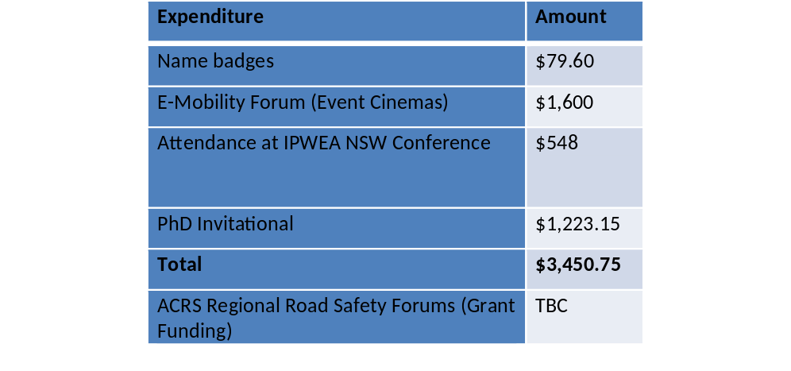
Note: Membership fees are paid to ACRS (national), not to state chapters.
The NSW Chapter bank account is managed by ACRS (national) who also approves all expenditure.
Refer to ACRS National Financial Statements (ACRS National AGM documentation) for more information and Auditors Report.

Membership Report
The total number of people (Individual & people within corporate membership) increased from 151 to 155.
Corporate membership (organisations) fell from 18 to 16.
Corporates should periodically review the list of people assigned ACRS membership as they are voting members.

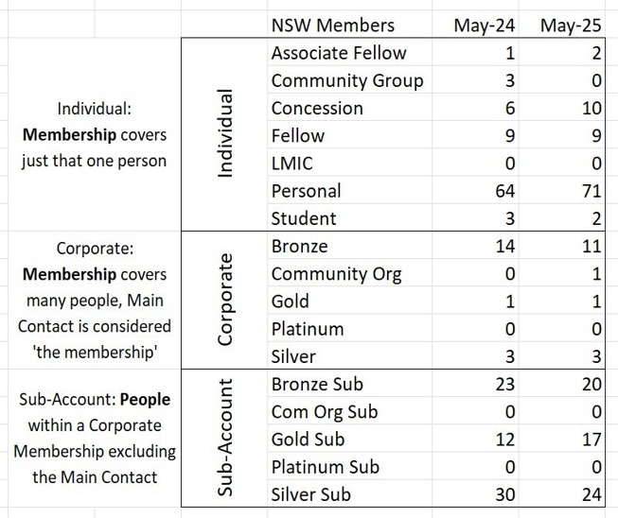

Motion: Move that the Chair’s Report (including treasury and membership) be accepted.
Moved: David McTiernan Seconded: Keith Simmons
Carried

Acknowledgements – Outgoing Committee Members
Josh Devitt
David McTiernan
Ralston Fernades

2025-26 Chapter Committee

Name | Position
Mr David Beck | Committee member
Dr John Crozier | Committee member, ACRS Fellow
Mr William Douglas | Committee member
Dr Cassandra Gauld | Committee member
Mr David Kennedy | Committee member
Dr Helen Nguyen | Committee member
Dr Tasha Prabhakar | Deputy Chair
Mr Brana Ravichelvan | Committee member
Mr Mick Timms | Chair
Mr David Wakelin | Secretary

Closed: 6pm

